Photobiomodulation

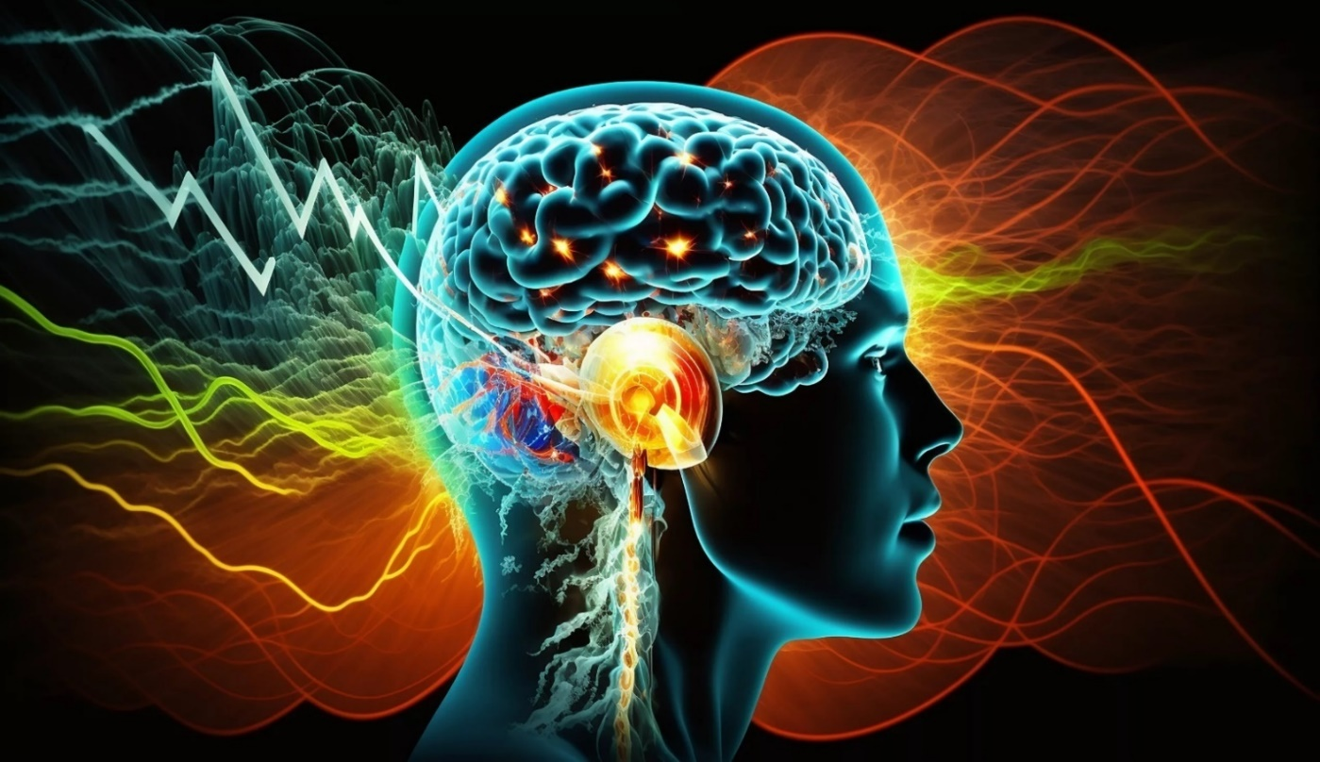
Does your daily grind leave you feeling fatigued, stressed or not as vibrant as you would like?

At GHS, we help you unlock your body’s resilience to stay young and fit for ever. Indulge in the dazzling experience of transformative lifestyle through photobiomodulation and harness its amazing benefits for a whole spectrum of medical conditions.

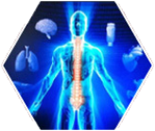
Stimulates endorphins
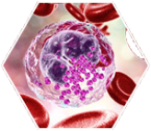
Enhances circulation
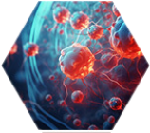
Accelerates tissue repair
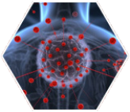
Reduces inflammation
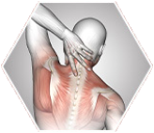
Alleviates muscle tension

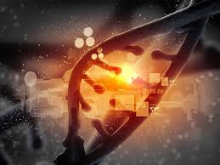
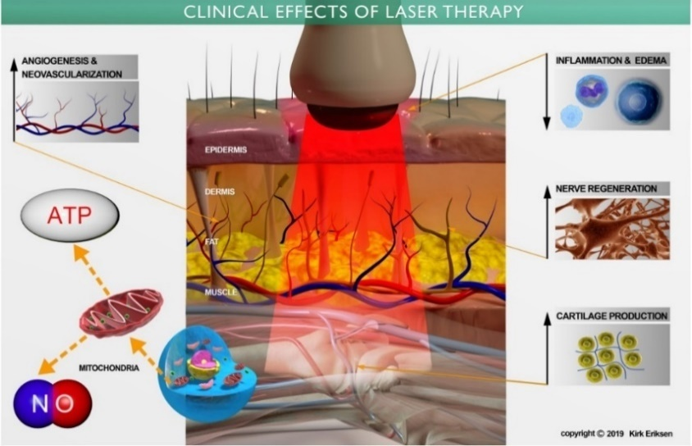

At GHS, we specialize in bringing the power of Red-Light Therapy (Photobiomodulation), Electromagnetic Stimulation and personalized recovery protocols that leverage cutting-edge rejuvenation technologies.
Our approach is designed for scientifically supported protocols with advanced human performance techniques, we offer transformative lifestyle experience that empowers our clients to restore optimal wellness.
GHS has played a leading role in photobiomodulation research and development in Canada and the US for over 10 years. In collaboration with a multi-disciplinary team of physicians, specialists, allied health care providers, clinical researchers, physicists and innovators, we have now developed the world’s first evidence based photobiomodulation protocol for the most effective use of laser energy which is backed by leading clinical research.

About Us

All our services will be provided under the supervision of family physicians and specialists, as medically necessary

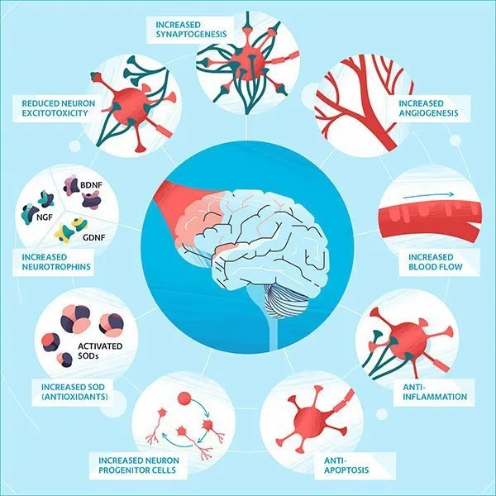
“Photobiomodulation (PBM) is a noninvasive photonic-based therapy, capable of dealing with immune-inflammatory, neurological, and musculoskeletal disorders, as well as healing oral and chronic skin wounds. During PBM light is applied at a specific wavelength, either in the visible or near-infrared (NIR) ranges. Photophysical and photochemical processes might stimulate or inhibit various biological processes, depending on the target tissue, the wavelength of light, irradiance, fluence, repetition rate (pulse frequency), spot size, optical data of the tissue to be irradiated and treatment regimen. There are several randomized clinical studies demonstrating the PBM benefits as main or adjuvant therapies.”
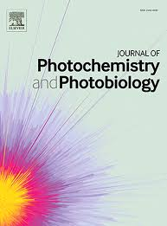
Authors: Felician M. C. P. et al.
Title: Photobiomodulation: Cellular, molecular, and clinical aspects.
Journal: Journal of Photochemistry and Photobiology, 2023.
Link: https://doi.org/10.1016/j.jpap.2023.100197

What is Photobiomodulation

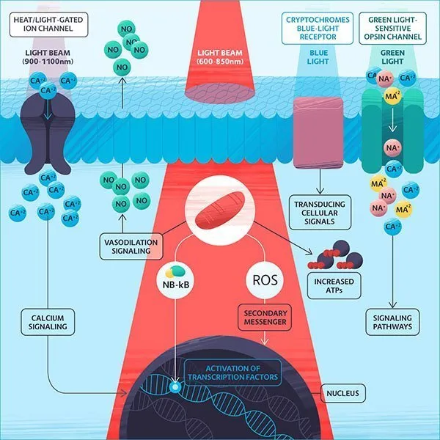

“Light gets absorbed by chromophores into the cell mitochondria via the cytochrome c oxidase, which is a primary photo-acceptor for the red and near infrared light range in mammalian cells. The absorption of light stimulates the electron transport chain, which leads to the synthesis of adenosine triphosphate (ATP), production of reactive oxygen species (ROS) and release of nitric oxide (NO). ROS are the free radicals and reactive molecules that originate from molecular oxygen produced during electron transport as by products. It was presumed that these molecules only have damaging effects in cell components, however, recently it has been demonstrated that ROS play significant and beneficial roles in cell signaling processes and other physiological processes. The induction of these molecules by LLLT have positive effects as they induce transcription factors like nuclear factor Kappa B (NF-kB) and activator protein-1 (AP-1), which in turn promote gene expression, thereby increasing protein synthesis, cell proliferation, cell migration, production of cytokines and growth factors, as well as increased tissue oxygenation. Furthermore, the absorption of photons by mammalian cells regulates enzymatic activity and also balances both intracellular and extracellular pH.”

Authors: Lugongolo, Masixole Yvonne et al.
Title: The combination of LLLT and efavirenz drastically reduces HIV infection in TZM-bl cells
Journal: Biomedical Journal, 2021

How it works
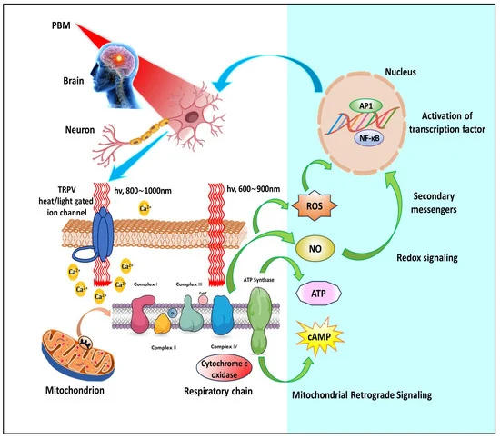
Figure 1. Cellular and molecular mechanisms underlying photobiomodulation. AP1, activator protein 1; ATP, adenosine triphosphate; Ca2+, calcium ions; cAMP, cyclic adenosine monophosphate; NF-κB, nuclear factor kappa B; NO, nitric oxide; ROS, reactive oxygen species; TRPV, transient receptor potential vanilloid.
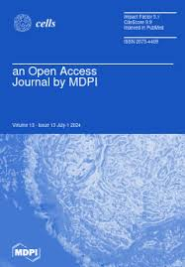

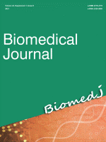

Authors: Nairuz T, Sangwoo-Cho, Lee J-H.
Title: Photobiomodulation Therapy on Brain: Pioneering an Innovative Approach to Revolutionize Cognitive Dynamics.
Journal: Cells. 2024
Link: https://doi.org/10.3390/cells13110966

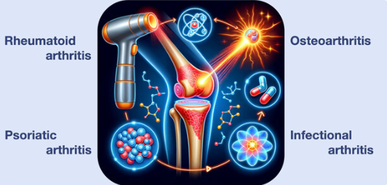
“Chronic pain is a problem that has a very notorious impact on society and people’s lives and is one of the most common health problems among older adults (>65 years).
PBM has shown a systemic response in addition to the local response, with improvements in quality of life, pain, sleep disorders, tiredness, muscle spasm, morning stiffness, psychological factors, elastic properties of tissue, circadian rhythms, tender points, and in fibromyalgia sufferers.
Furthermore, PBM therapy has also been shown to improve cerebral blood flow, neuronal bioenergetic functions, neuroinflammation, oxidative stress, neural apoptosis, neurogenesis, and neurotrophic factors, and additionally has effects on intrinsic brain networks. In addition, PBM is also thought to affect the secretion of certain hormones, such as serotonin and endorphins, leading to a reduction in pain signaling.”
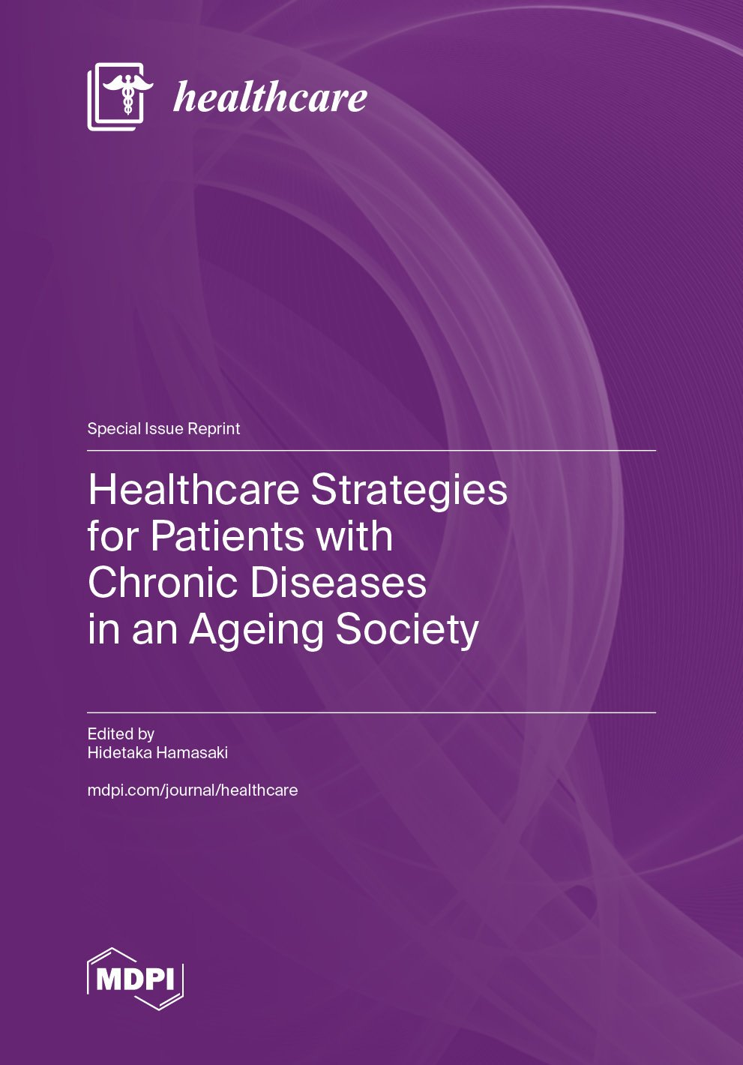
Authors: González-Muñoz A, Cuevas-Cervera M, Pérez-Montilla JJ, et al.
Title: Efficacy of Photobiomodulation Therapy in the Treatment of Pain and Inflammation: A Literature Review.
Journal: Healthcare (Basel). 2023
Link: https://www.ncbi.nlm.nih.gov/pmc/articles/PMC10094541/

Pain
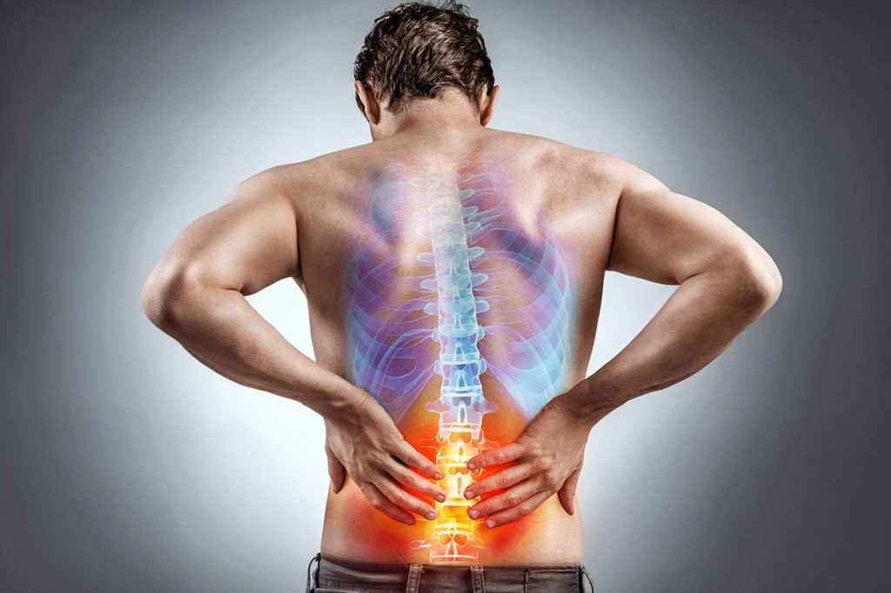
“In recent years, evidence for the use of light therapy as a nonpharmacologic approach for pain reduction has gained momentum, and both preclinical and clinical studies have demonstrated its efficacy and continue to explore its efficacy in a variety of pain syndromes.”
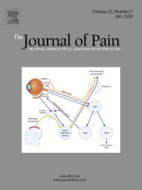
Authors: Cheng K, Martin LF, Slepian MJ, Patwardhan AM, Ibrahim MM
Title: Mechanisms and Pathways of Pain Photobiomodulation: A Narrative Review.
Journal: Journal of Pain, 2021
Link: https://pubmed.ncbi.nlm.nih.gov/33636371/

“Nineteen RCTs involving 1089 participants were included in this review. PBMT alone or with exercise improved pain intensity in short-term treatment. PBMT was superior to (extracorporeal shock wave therapy) EWST for relief of pain.”

Authors: Ferlito, J.V., Silva, C.F., Almeida, J.C. et al.
Title: Effects of photobiomodulation therapy (PBMT) on the management of pain intensity and disability in plantar fasciitis: systematic review and meta-analysis.
Journal: Lasers in Medical Science 2023
Link: https://doi.org/10.1007/s10103-023-03823-0

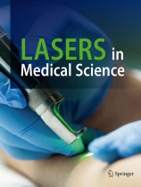

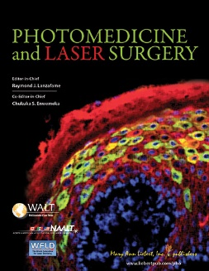
“Over the years more than 100 double-blind, placebo-controlled studies have been published on the effects of LLLT. These articles also showed the favorable anti-inflammatory effect of LLLT”

Authors: Hegedus B, Viharos L, Gervain M, Gálfi M.
Title: The effect of low-level laser in knee osteoarthritis: a double-blind, randomized, placebo-controlled trial.
Journal: Photomedicine and Laser Surgery 2009
Link: https://www.ncbi.nlm.nih.gov/pmc/articles/PMC2957068/

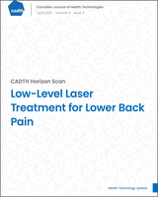
“Participants from the randomized double-blind sham-controlled study were followed up at 12 months to determine the effectiveness of the Erchonia FX 635, and showed the therapeutic effects of the laser therapy were maintained after a year”

Authors: Candice Madakadze, and Sharon Bailey
Title: Low-Level Laser Treatment for Lower Back Pain
Journal: Canadian Agency for Drugs and Technologies in Health 2023
Link: https://www.ncbi.nlm.nih.gov/books/NBK596638/


“LLLT significantly reduces pain and disability in lower extremity tendinopathy and plantar fasciitis in the short and medium term.”

Authors: Naterstad IF, Joensen J, Bjordal JM, Couppé C, Lopes-Martins RAB, Stausholm MB.
Title: Efficacy of low-level laser therapy in patients with lower extremity tendinopathy or plantar fasciitis: systematic review and meta-analysis of randomised controlled trials.
Journal: BMJ Open 2022
Link: https://pubmed.ncbi.nlm.nih.gov/36171024/

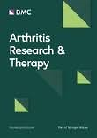
“Our findings indicate that LLLT is an effective method for relieving pain in NSCLBP patients.”

Authors: Huang Z, Ma J, Chen J, Shen B, Pei F, Kraus VB.
Title: The effectiveness of low-level laser therapy for nonspecific chronic low back pain: a systematic review and meta-analysis.
Journal: Arthritis Research & Therapy 2015
Link: https://www.ncbi.nlm.nih.gov/pmc/articles/PMC4704537/

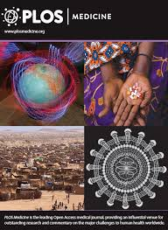
“LLLT has promising results in controlling joint inflammation, reducing pain, tumor necrosis factor alpha (TNF-a) and modulating the inflammatory process.”

Authors: Lourinho I, Sousa T, Jardim R, Pinto AC, Iosimuta N.
Title: Effects of low-level laser therapy in adults with rheumatoid arthritis: A systematic review and meta-analysis of controlled trials.
Journal: PLoS One 2023
Link: https://www.ncbi.nlm.nih.gov/pmc/articles/PMC10490856/

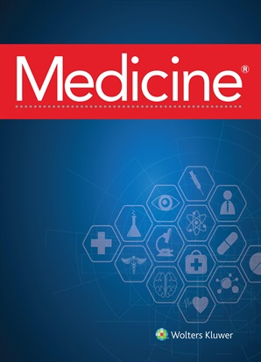
“Due to the high prevalence of children with TMD, we can treat this condition with ILIB, which is inexpensive, safe and has no side effects; there is also evidence on the systemic effect regarding the improvement in the body’s response in repair and inflammation, aiding in cases of decreased mandibular opening.”

Authors: Sertaje MRF, Gonçalves MLL, Gomes AO, et al.
Title: Vascular photobiomodulation in the treatment of children with temporomandibular disorders: Study protocol for a randomized, controlled, blind, clinical trial.
Journal: Medicine (Baltimore), 2022
Link: https://pubmed.ncbi.nlm.nih.gov/36281107/

“PBM is an effective analgesic non-pharmacological therapy, which can be safely and easily applied by a qualified professional.”

Authors: Amorim ACFG, Belchior TCF, Silva Rodarte TND, et al.
Title: Photobiomodulation therapy for chronic knee pain in obese patients in pre-rehabilitation for bariatric surgery: randomised, placebo-controlled, double-blinded, clinical trial protocol.
Journal: BMJ Open 2024
Link: https://www.ncbi.nlm.nih.gov/pmc/articles/PMC11328612/

“The use of laser therapy in patients with facial pain showed pain relief within minutes after its application, providing a significant well-being state.”

Authors: Costanti Vilela Campos M, Simoes Velloso Schuler S, de Barros Motta P, et al.
Title: The effect of systemic versus local transcutaneous laser therapy on tension-type cephalea and orofacial pain in post-COVID-19 patients: A pragmatic randomized clinical trial.
Journal: Medicine (Baltimore), 2022
Link: https://www.ncbi.nlm.nih.gov/pmc/articles/PMC9678397/

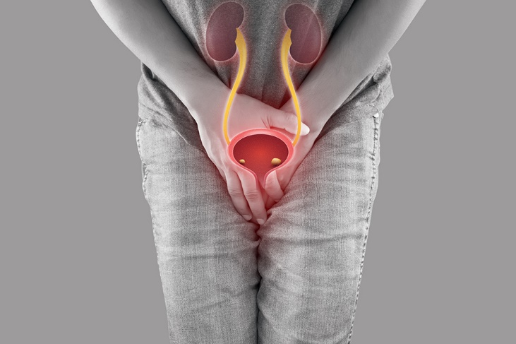
“The major uses are in urolithiasis, benign prostatic enlargement (BPE), and management of many urological malignancies and other benign pathologies.
Lasers have become an established treatment modality in urolithiasis, an acceptable alternative with the least side effect profile in BPE patients, and a novel and promising therapy in many other fields of Urology.”

Authors: Puliyath, N., Venugopalan, A.V., Das KV, S. et al.
Title: The thermal effect of lasers in urology: a review article.
Journal: Lasers in Medical Science, 2023
Link: https://doi.org/10.1007/s10103-023-03948-2

Urology
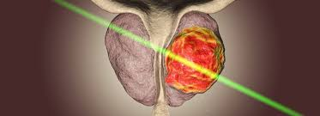

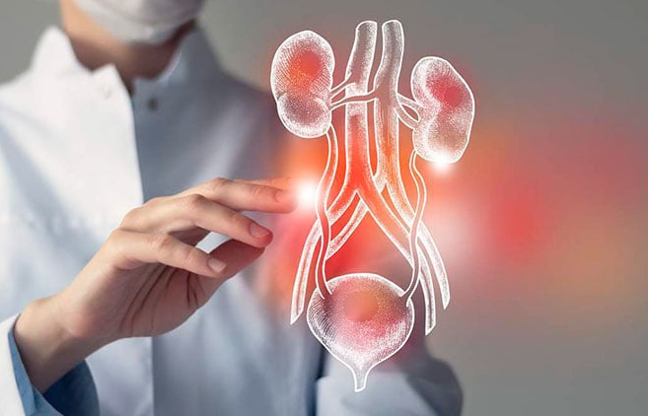

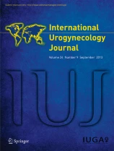
“Our results suggest that a single maintenance laser treatment for reducing symptoms of SUI is transiently effective, well tolerated and safe.”
(SUI: Stress Urinary Incontinence)

Authors: Lauterbach R, Aharoni S, Justman N, Farago N, Gruenwald I, Lowenstein L.
Title: The efficacy and safety of a single maintenance laser treatment for stress urinary incontinence: a double-blinded randomized controlled trial
Journal: International Urogynecology Journal 2022
Link: https://www.ncbi.nlm.nih.gov/pmc/articles/PMC5992952/

“Lasers have become an established treatment modality in urolithiasis, an acceptable alternative with the least side effect profile in BPE patients, and a novel and promising therapy in many other fields of Urology.”
(BPE: Benign prostatic enlargement)

Authors: Puliyath, N., Venugopalan, A.V., Das KV, S. et al.
Title: The thermal effect of lasers in urology: a review article.
Journal: Lasers in Medical Science, 2023
Link: https://doi.org/10.1007/s10103-023-03948-2

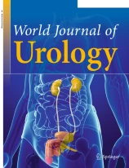
“The introduction of laser technologies in recent years has enabled the development of new surgical techniques for the treatment of BPH and thus alternatives to conventional transurethral resection of the prostate.”

Authors: Reichelt, A.C., Suarez-Ibarrola, R., Herrmann, T.R.W. et al.
Title: Laser procedures in the treatment of BPH: a bibliometric study.
Journal: World Journal of Urology, 2021
Link: https://doi.org/10.1007/s00345-020-03532-1

“There was a statistically signiﬁcant reduction in the number of UUIs and incontinence episodes, which are the key symptoms of OAB.”
(UUI: urge urinary incontinence, OAB: Overactive bladder)

Authors: Hwang WY, Kim YB, Lee SR, Suh DH, Kim K, No JH.
Title: Efficacy and safety of skin-adhesive low-level light therapy for overactive bladder: a Phase III study.
Journal: International Urogynecology Journal 2022
Link: https://www.ncbi.nlm.nih.gov/pmc/articles/PMC9666307/

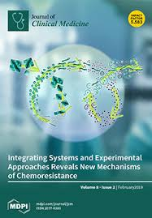
“Transperineal laser ablation of the prostate is an innovative minimally invasive treatment option for BPE that showed interesting and promising results.”

Authors: Tafuri A, Panunzio A, De Carlo F, et al.
Title: Transperineal Laser Ablation for Benign Prostatic Enlargement: A Systematic Review and Pooled Analysis of Pilot Studies.
Journal: Journal of Clinical Medicine, 2023
Link: https://www.ncbi.nlm.nih.gov/pmc/articles/PMC10003190/

“The latest addition to laser therapy for BPH is photoselective vaporization of the prostate. This procedure results in rapid vaporization of prostate tissue with good outcome up to 5 yr reported.

Authors: de la Rosette, Jean et al
Title: Historical Aspects of Laser Therapy for Benign Prostatic Hyperplasia
Journal: European Urology Supplements, 2008
Link: https://www.ncbi.nlm.nih.gov/pmc/articles/PMC10003190/

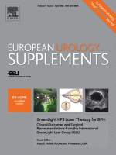

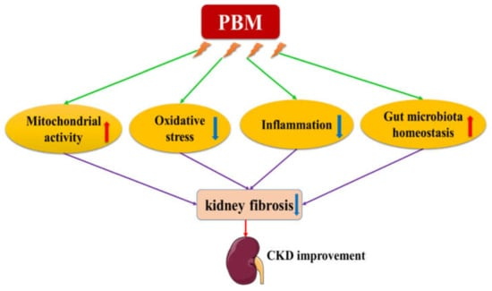
Figure 1. Potential mechanisms of the therapeutic effects of PBM on CKD. PBM may improve kidney function by promoting mitochondrial activity, suppressing oxidative stress, inhibiting inflammation, and restoring gut microbiota homeostasis.

“The present study suggests that PBM directly reduced inflammation and fibrosis in kidney tubular cells, when used at the appropriate dose.”

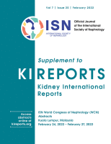

Authors: J. BIAN, C. Pollock, C. Huang, A. Liebert, X.M. Chen,
Title: POS-360 The role of Photobiomodulation on chronic kidney disease
Journal: Kidney International Reports, 2022
Link: https://doi.org/10.1016/j.ekir.2022.01.382

“Chronic kidney disease (CKD) is a growing global public health problem. The implementation of evidence-based clinical practices only defers the development of kidney failure. Death, transplantation, or dialysis are the consequences of kidney failure, resulting in a significant burden on the health system.
PBM has been shown over decades to be a patient-directed, adjunctive, effective, non-invasive, and safe treatment option to mitigate mitochondrial dysfunction, oxidative stress, inflammatory conditions, and, more recently, gut microbiota dysbiosis, which are all primary contributors to CKD. Notably, several studies have demonstrated a positive effect of PBM in different models of kidney diseases, including acute kidney injury, glomerulonephritis, and metabolic syndrome-related kidney injury.”
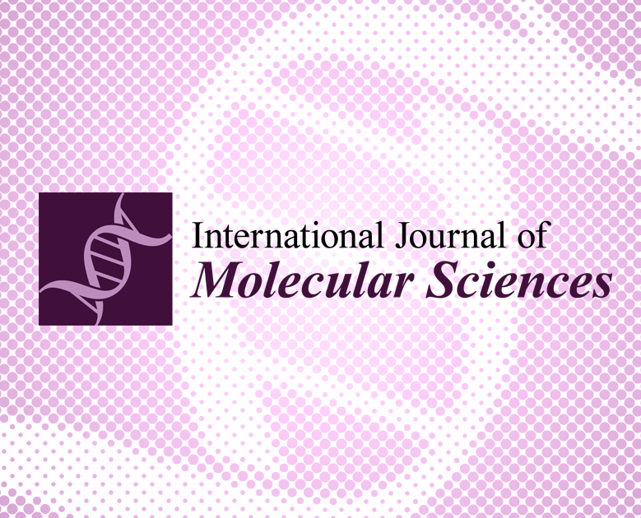
Authors: Bian J, Liebert A, Bicknell B, Chen XM, Huang C, Pollock CA.
Title: Therapeutic Potential of Photobiomodulation for Chronic Kidney Disease.
Journal: International Journal of Molecular Sciences, 2022
Link: https://doi.org/10.3390/ijms23148043

Nephrology

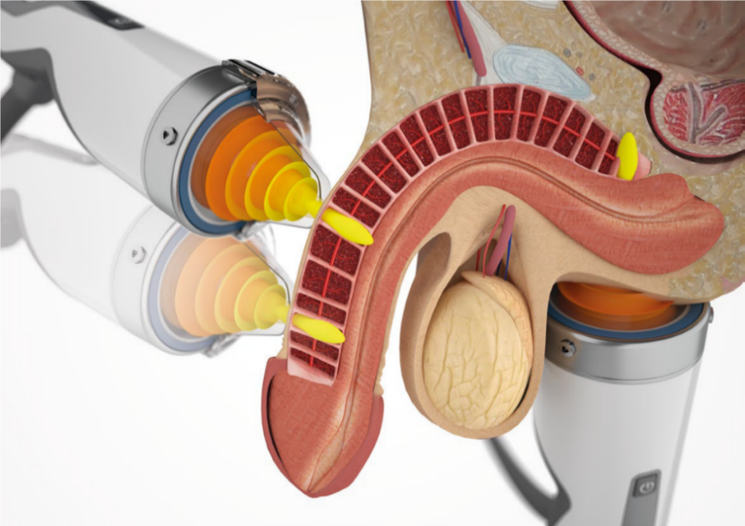



“The leading factors that cause male infertility are urogenital infections, disorders of the immune system, testicular and prostate pathology, as well as endocrine disorders.
Low level laser therapy (LLLT) is a very effective physical therapy method, used in many areas of medicine, including obstetrics and gynaecology, andrology and urology; and it is recommended as an integral part of the complex treatment of infertility.
Laser can significantly improve the survival, motility and speed of movement of spermatozoa. Laser therapy of patients with prostatitis and vesiculitis can eliminate infiltrative-exudative changes, improve reproductive and copulatory functions.”
Authors: Lauterbach R, Aharoni S, Justman N, Farago N, Gruenwald I, Lowenstein L.
Title: The efficacy and safety of a single maintenance laser treatment for stress urinary incontinence: a double-blinded randomized controlled trial
Journal: International Urogynecology Journal 2022
Link: https://www.ncbi.nlm.nih.gov/pmc/articles/PMC5992952/

Male infertility & Erectile Dysfunction
“Laser therapy should be used as much as possible in the complex treatment of men with infertility, since the effectiveness of the method is not just high, but often has no alternatives.”

Authors: Moskvin SV, Apolikhin OI
Title: Effectiveness of low level laser therapy for treating male infertility.
Journal: Biomedicine 2018
Link: https://www.ncbi.nlm.nih.gov/pmc/articles/PMC5992952/

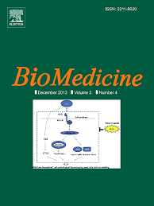

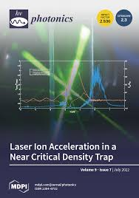
“The magnitude of the positive effect of tPBM on SD were much faster and far greater than for its effect on depression.”
(tPBM: transcranial Photobiomodulation, SD: sexual dysfunction)

Authors: Salehpour F, Khademi M, Vahedifard F, Cassano P.
Title: Transcranial Photobiomodulation Therapy for Sexual Dysfunction Associated with Depression or Induced by Antidepressant Medications
Journal: Photonics, 2022
Link: https://doi.org/10.3390/photonics9050330

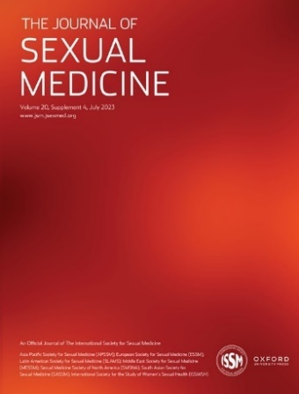
“HILT seems to be effective in improving erectile function in patients suffering from mild-to-severe ED”
(HILT: high intensity laser therapy, ED: erectile dysfunction)

Authors: Bhandari Dr. Chirag
Title: High Intensity laser therapy improves Erectile function in short term: a pilot study
Journal: The Journal of Sexual Medicine, 2023
Link: https://doi.org/10.1093/jsxmed/qdad062.150

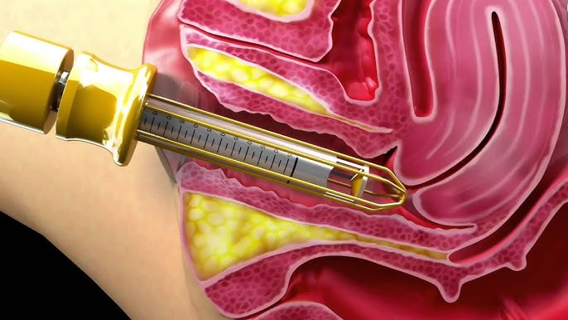
“Vaginal lasers heat the vaginal epithelium and cause thermal necrosis, which induces collagen remodelling and synthesis, neovascularization and elastin formation. This may lead to improved vaginal elasticity and restoration of premenopausal epithelial function”


Authors: Welk B, Kelly E.
Title: Laser devices for vaginal rejuvenation: effectiveness, regulation and marketing.
Journal: CMAJ, 2023
Link: https://doi.org/10.1503/cmaj.221208

“Vaginal rejuvenation has been popped up recently due to the increase in life expectancy and the search for a better quality of life. Nowadays, women live one-third of their lives after menopause, demanding efforts to keep their sexual life up to their body and mind’s health. Advances in laser therapy have made this possible, reversing vulvovaginal atrophy and its symptoms, known as genitourinary syndrome of menopause, including vaginal dryness, dyspareunia, decrease in sexual arousal and orgasm, stress urinary incontinence, and vaginal bleeding. Carbon dioxide laser (CO₂) and the erbium laser (Er:YAG) are the most common lasers used for female rejuvenation. They promote neocollagenesis and neovascularization in the connective tissue of the vaginal wall, as well as recover the mucosal epithelium, restoring lubrication and elasticity of vaginal walls.”
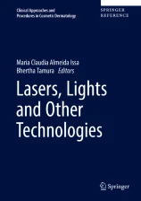

Authors: de Assis Florentino, A.V., Lage Bicalho Bretas, T., Issa, M.C.A.
Title: Lasers for Aesthetic and Functional Vaginal Rejuvenation.
Journal: Lasers, Lights and Other Technologies. Clinical Approaches and Procedures in Cosmetic Dermatology, 2018
Link: https://doi.org/10.1007/978-3-319-16799-2_40

Vaginal Rejuvenation
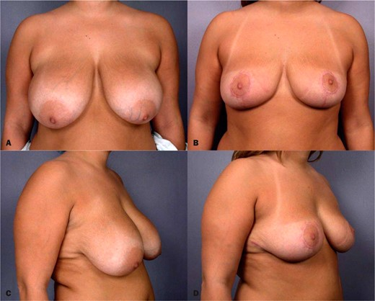A, C, Preooperative views of a 26-year-old woman. B, D, Postoperative views 5 months after laser-assisted breast reduction with removal of 455 g from the right breast and 485 g from the left breast.
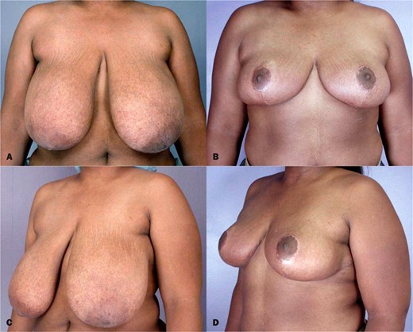A, C, Preoperative views of a 29-year-old woman. B, D, Postoperative views 6 months after laser-assisted breast reduction with removal of 970 g from the right breast and 1265 g from the left breast.
Laser-assisted breast reduction surgery, while not a widely utilized technique, has a number of traits that make it a viable alternative to standard scalpel or scissor deepithelialization. As mentioned previously, these traits include essentially bloodless deepithelialization, predictable preservation of the subdermal vascular plexus, a firm dermal leash, and the ability to deepithelialize without the need for assistance or taut immobilization of the breasts.
Complication rates for our series of patients who underwent laser-assisted breast reduction surgery were consistent with those reported for non–laser-assisted procedures. These results, combined with the benefits and efficient operating time afforded by laser deepithelialization, indicate that laser-assisted breast reduction surgery can provide an alternative to standard methods of deepithelialization.


Authors: Stevens WG, Cohen R, Schantz SA, et al.
Title: Laser-Assisted Breast Reduction: A Safe and Effective Alternative. A Study of 367 Patients
Journal: Aesthetic Surgery Journal, 2006
Link: https://doi.org/10.1016/j.asj.2006.06.006

Breast Reduction
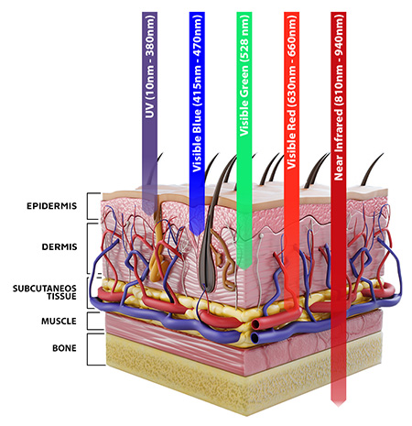
“Photobiomodulation (PBM), synonymous with low-level light (laser) therapy (LLLT) has gained traction as a noninvasive therapy for skin rejuvenation, including treatment of facial rhytids, dyschromia’s, and acne vulgaris; wound healing including scar management; body contouring (either alone or as a means of enhancing the removal of fat during liposculpture); and androgenic alopecia. The therapeutic potential of PBM is becoming generally accepted as clinical trial data continues to provide evidence of efficacy and safety.”
Author: Graeme Ewan Glass, PhD, FRCS (Plast)
Title: Photobiomodulation: A Systematic Review of the Oncologic Safety of Low-Level Light Therapy for Aesthetic Skin Rejuvenation,
Journal: Aesthetic Surgery Journal, 2023
Link: https://doi.org/10.1093/asj/sjad018

Dermatology
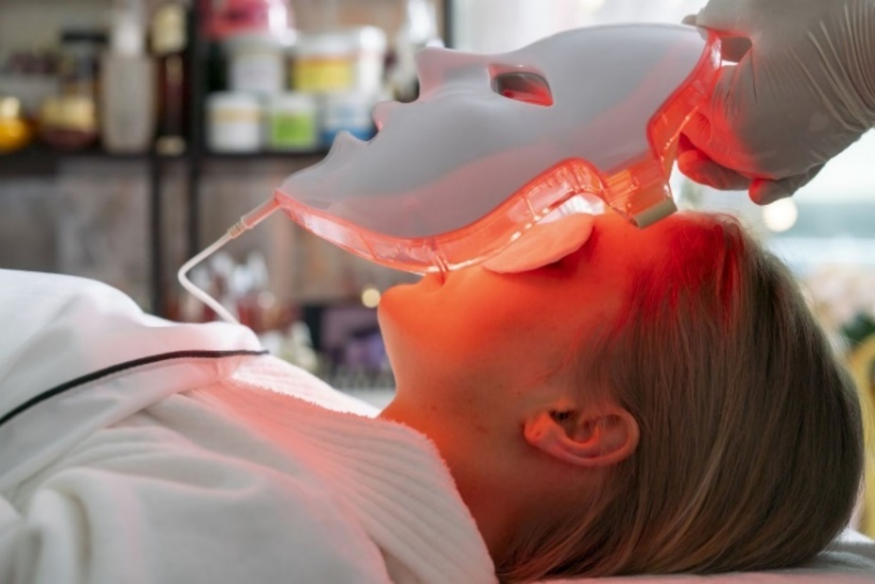

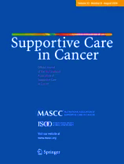
“Preventive PBMT may be protective against the development of severe grades of RD and reduce the frequency of RT interruptions.”

Authors: Gobbo, M., Rico, V., Marta, G.N. et al.
Title: Photobiomodulation therapy for the prevention of acute radiation dermatitis: a systematic review and meta-analysis.
Journal: Support Care Cancer 2023.
Link: https://doi.org/10.1007/s00520-023-07673-y

“In addition to the expected effects on collagen production in dermal fibroblasts leading to a reduction in fine lines and wrinkles, beneficial effects on hyperpigmented spots have also been observed.”

Author: Hamblin MR.
Title: Photobiomodulation for Skin Pigmentation Disorders: A Dual-Function Treatment.
Journal: Photobiomodulation, Photomedicine, and Laser Surgery 2023
Link: https://www.ncbi.nlm.nih.gov/pmc/articles/PMC10171961/

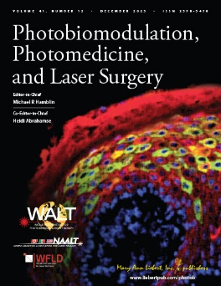

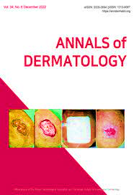
“Androgenetic alopecia (AGA) leads to thinning of scalp hair and affects 60%~70% of the adult population worldwide.
Red light of 650 nm promoted human hair growth and inhibited spontaneous catagen transition in ex vivo HFs.”

Authors: Yang K, Tang Y, Ma Y, et al.
Title: Hair Growth Promoting Effects of 650 nm Red Light Stimulation on Human Hair Follicles and Study of Its Mechanisms via RNA Sequencing Transcriptome Analysis.
Journal: Clinical, Cosmetic and Investigational Dermatology 2021
Link: https://pubmed.ncbi.nlm.nih.gov/34858007/

“In 16 studies with 25 cell lines, the influence of PBM on neoplastic cell viability was examined. PBM was found to reduce the viability of 13 of 25 neoplastic cell lines either in isolation or in the presence of another experimental agent.”

Author: Graeme Ewan Glass, PhD, FRCS (Plast)
Title: Photobiomodulation: A Systematic Review of the Oncologic Safety of Low-Level Light Therapy for Aesthetic Skin Rejuvenation
Journal: Aesthetic Surgery Journal 2023
Link: https://doi.org/10.1093/asj/sjad018
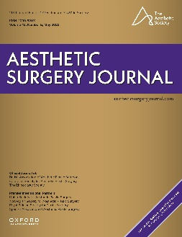
““A series of six treatments using a near-infrared low-level laser represents a safe and effective non-invasive therapy option for acne vulgaris. It has also been proven that phototherapy can significantly affect the activity of sebaceous glands and reduce the keratosis of the hair follicles outlets”
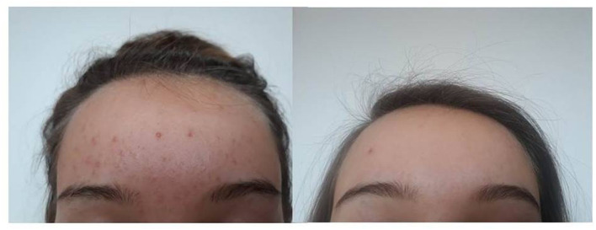
Patient no. 1, a 19-year-old woman, before commencement of the study and two weeks after completion of the series of six treatments using a low level laser.

Authors: Szymańska A, Budzisz E, Erkiert-Polguj A.
Title: The Anti-Acne Effect of Near-Infrared Low-Level Laser Therapy.
Journal: Clinical, Cosmetic and Investigational Dermatology 2021

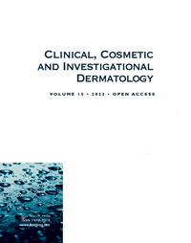

“In order to reverse the visible signs of skin aging, the use of Low‐Level Laser Therapy (LLLT) is becoming more and more common and numerous clinical studies demonstrate its effectiveness. This clinical study confirms the interest of photobiomodulation in the treatment of the signs of skin aging. From the very first sessions, whatever the age of the person, the visible effects of reversing the signs of aging are not only observable but also measurable.”
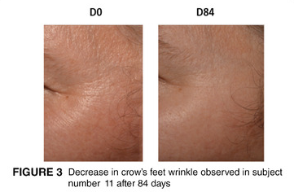
Author: Couturaud V, Le Fur M, Pelletier M, Granotier F.
Title: Reverse skin aging signs by red light photobiomodulation.
Journal: Aesthetic Surgery Journal 2023

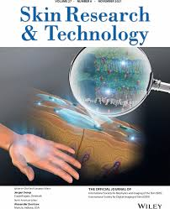
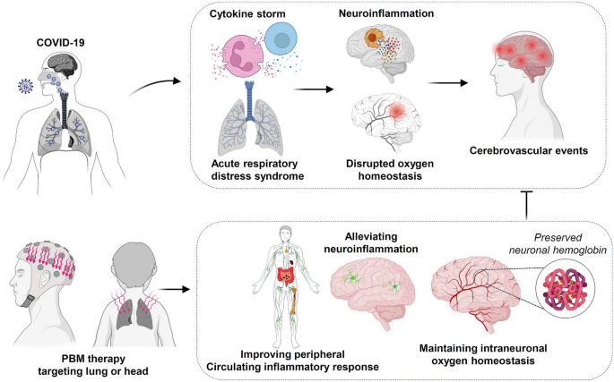
PBM may alleviate neurological events following COVID-19 infection by targeting inflammatory responses and oxygen homeostasis. Hypoxia caused by Coronavirus SARS-CoV-2 infection and inflammation-related changes in brain tissue are essential in triggering cerebrovascular events. PBM targeting the lung or head could alleviate the cytokine storm and maintain intraneuronal oxygen homeostasis by preserving neuronal hemoglobin.
“Photobiomodulation (PBM) therapy, also known as low-level laser therapy, is a widely studied non-invasive method with anti-inflammatory and antioxidant properties.
Currently, the leading hypothesis to explain how PBM works proposes that mitochondrial cytochrome c oxidase (CCO) is its primary target. According to the hypothesis, the mitochondrial CCO absorbs near-infrared photons and releases nitric oxide (NO) to relieve the inhibitory effects of NO on CCO activity. The displacement of inhibitory NO promotes the efficiency of the electron transport chain and alleviates the release of reactive oxygen species, followed by decreased oxidative damage and inflammation.
PBM treatment significantly preserves mitochondrial function, neuronal hemoglobin, and intraneuronal oxygen homeostasis.”
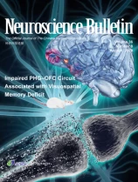
Authors: Wu, C., Liu, T.CY., Duan, R. et al
Title: Photobiomodulation: A Potential Non-invasive Method to Alleviate Neurological Events Following COVID-19 Infection.
Journal: Neuroscience Bulletin, 2023
Link: https://doi.org/10.1007/s12264-023-01064-3

Infectious disease

“Photobiomodulation therapy of herpes labialis reduced pain significantly faster than acyclovir.”

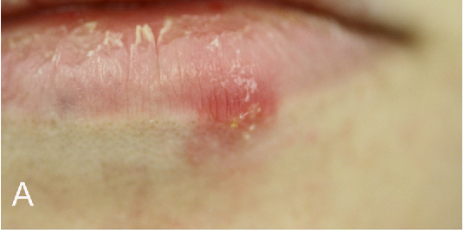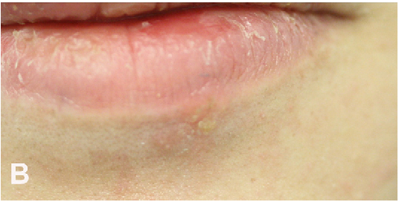

Authors: Gaizeh Al-Hallak, M.A., Chalhoub, K., Hsaian, J.A. et al.
Title: Efficacy of photobiomodulation therapy in recurrent herpes labialis management: a randomized controlled trial
Journal: Clinical Oral Investigations, 2024
Link: https://doi.org/10.1007/s00784-024-05541-5

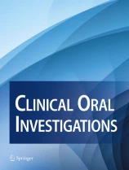

“Overall, low-level laser therapy (LLLT) proved itself an excellent therapeutic modality for the relief of pain in post-herpetic neuralgia patients, which may replace pain management medicines in future.”
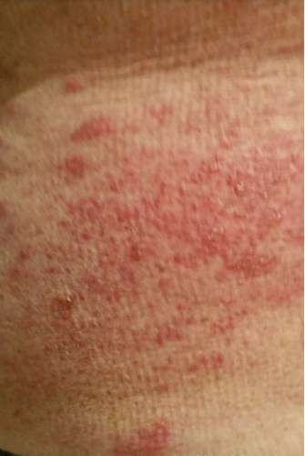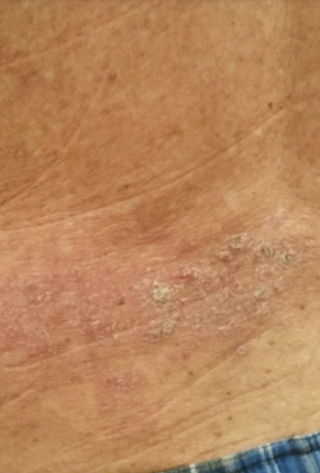

Authors: Mukhtar R, Fazal MU, Saleem M, Saleem S.
Title: Role of low-level laser therapy in post-herpetic neuralgia: a pilot study.
Journal: Lasers in Medical Science, 2020
Link: https://pubmed.ncbi.nlm.nih.gov/32006261/

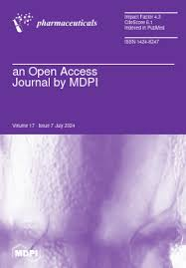
“Light-mediated treatments are suitable to manage both oncogenic viral infections and induced neoplasia.”

Authors: Mfouo-Tynga IS, Mouinga-Ondeme AG.
Title: Photodynamic Therapy: A Prospective Therapeutic Approach for Viral Infections and Induced Neoplasia.
Journal: Pharmaceuticals (Basel), 2022
Link: https://doi.org/10.1007/s00784-024-05541-5

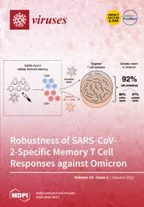
“Human coronaviruses (HCoVs) are also susceptible to photodynamic inactivation.”

Authors: Duguay BA, Herod A, Pringle ES, et al.
Title: Photodynamic Inactivation of Human Coronaviruses.
Journal: Viruses, 2022
Link: https://www.ncbi.nlm.nih.gov/pmc/articles/PMC8779093/

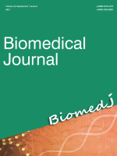
“Efavirenz and Low-level laser therapy significantly reduced HIV infection in TZM-bl cells. Furthermore, the death of HIV infected cells was due to necrosis.”

Authors: Lugongolo, Masixole Yvonne et al.
Title: The combination of low level laser therapy and efavirenz drastically reduces HIV infection in TZM-bl cells
Journal: Biomedical Journal, 2021
Link: https://pubmed.ncbi.nlm.nih.gov/35735083/

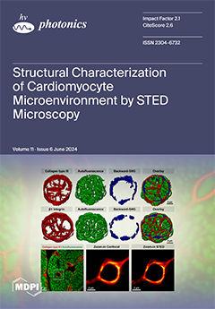
“This review revealed that Photobiomodulation has been successfully applied as adjunct therapy, in combination with conventional medical treatment, and as a pioneering action in SARS-CoV-2 infection, demonstrating significant improvements in airway inflammation and general clinical condition of patients, a faster recovery, avoiding intensive care unit (ICU) hospitalization, mechanical ventilation, mortality, and overcoming long-term sequelae.”

Authors: Ailioaie LM, Ailioaie C, Litscher G.
Title: Light as a Cure in COVID-19: A Challenge for Medicine.
Journal: Photonics. 2022
Link: https://doi.org/10.3390/photonics9100686

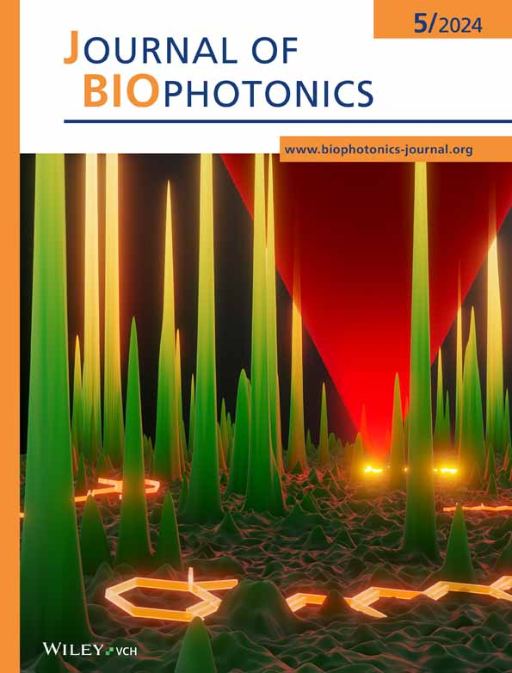
“Photobiomodulation therapy (PBMT) has been widely used to improve strength, fatigue resistance and increase muscle mass in healthy individuals. These effects could help critically ill patients admitted to intensive care units (ICUs) who show reduced mobility and muscle strength. ICU-acquired weakness lessens overall health and increases the patient's length of stay in the ICU.
The results suggest that daily PBMT can reduce the length of stay of ICU patients and increase muscle strength and mobility.”

Authors: Neto RPM, Espósito LMB, da Rocha FC, et al.
Title: Photobiomodulation therapy (red/NIR LEDs) reduced the length of stay in intensive care unit and improved muscle function: A randomized, triple-blind, and sham-controlled trial.
Journal: Journal of Biophotonics, 2024
Link: https://doi.org/10.1002/jbio.202300501

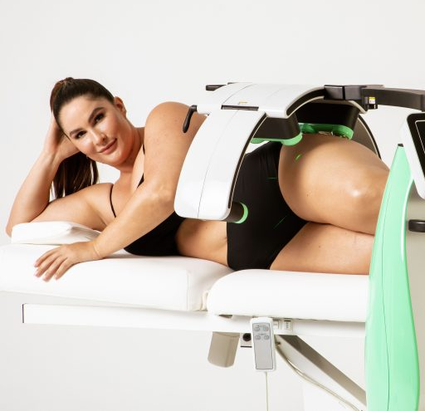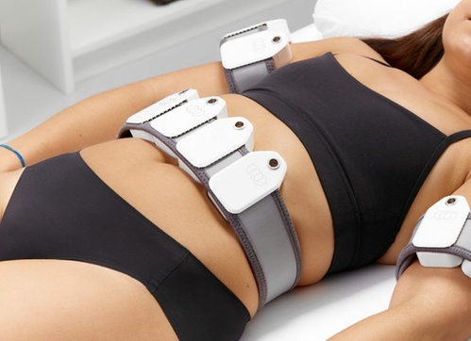

“Laser phototherapy is an irradiation approach to the blood that has been used to handle many rheological, neurological, and metabolic cases by enhancing lipoprotein lipase manufacturing, vasodilator release, and microcirculation improvement, additionally reducing the risk of metabolic complications and obesity-related comorbidities through boosting anti-inflammatory mediators, reduction in fat deposits, and lower serum lipids.”

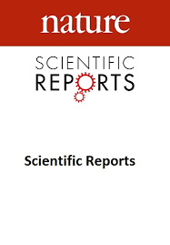
Authors: Elsayed MM, Abdallah GA, Hassan SS, Nagy EN.
Title: Effect of exercise training with laser phototherapy on homeostasis balance resistant to hypercoagulability in seniors with obesity: a randomized trial.
Journal: Scientific Reports 2023
Link: https://www.ncbi.nlm.nih.gov/pmc/articles/PMC9984371/

Obesity
“Providing 12 Low-level laser therapy treatments over the course of 6 weeks twice per week is effective for reducing body weight, BMI, body fat mass, and percent body fat as well as improving body satisfaction, body appreciation, and overall quality of life.”

Authors: Croghan IT, Hurt RT, Schroeder DR, Fokken SC, Jensen MD, Clark MM, Ebbert JO.
Title: Low-level laser therapy for weight reduction: a randomized pilot study.
Journal: Lasers in Medical Science 2020
Link: https://pubmed.ncbi.nlm.nih.gov/31473867/

“Subjects with BMI between 30 and 40 kg/m2 were treated with LLLT or sham treatment twice weekly for 3 weeks. Among subjects treated with the LLLT device, 71.43% attained a ‡3.0 inch decrease in combined circumference measurements versus 12% of sham-treated subjects.”

Authors: Roche GC, Shanks S, Jackson RF, Holsey LJ.
Title: Low-Level Laser Therapy for Reducing the Hip, Waist, and Upper Abdomen Circumference of Individuals with Obesity.
Journal: Photomedicine and Laser Surgery 2017
Link: https://doi.org/10.1089/pho.2016.4172

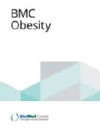
“From baseline to end of treatment, significant reductions in waist circumference were noted for each treatment group.”

Authors: Croghan IT, Ebbert JO, Schroeder DR, Hurt RT, Hagstrom V, Clark MM.
Title: A randomized, open-label pilot of the combination of low-level laser therapy and lorcaserin for weight loss
Journal: BMC Obesity 2016
Link: https://pubmed.ncbi.nlm.nih.gov/27708788/

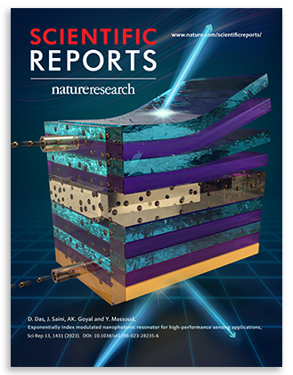
“The findings revealed a significant decrease (p < 0.001) in the participants' body measurements (WHR, weight, and BMI).”

Authors: Elsayed MM, Abdallah GA, Hassan SS, Nagy EN.
Title: Effect of exercise training with laser phototherapy on homeostasis balance resistant to hypercoagulability in seniors with obesity: a randomized trial.
Journal: Scientific Reports 2023
Link: https://www.ncbi.nlm.nih.gov/pmc/articles/PMC9984371/

“A combined treatment of Low-level laser therapy and diet may offer a safe and effective treatment modality for obese patients with lumbar disc prolapse.”

Authors: Gamaleldin, Haytham & Nasef, Samy & Shaban, Ghada & Elaggan, Ashraf.
Title: Effect of Low level laser on abdominal obesity in women with lumbar disc prolapse: A Randomized Controlled Trial
Journal: European Journal of Molecular & Clinical Medicine 2021

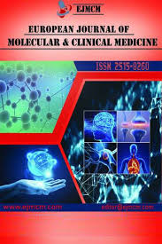

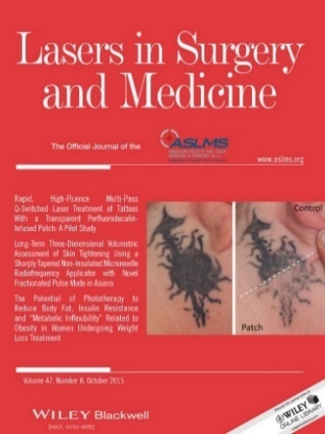
“Phototherapy enhances the physical exercise effects in obese women undergoing weight loss treatment promoting significant changes in inflexibility metabolic profile.”

Authors: Sene-Fiorese M, Duarte FO, de Aquino Junior AE, et al.
Title: The potential of phototherapy to reduce body fat, insulin resistance and "metabolic inflexibility" related to obesity in women undergoing weight loss treatment
Journal: Lasers in Surgery and Medicine 2015
Link: https://doi.org/10.1002/lsm.22395

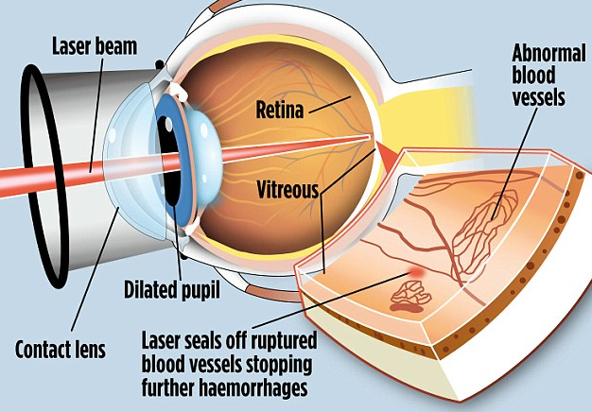

“Clinical trials assessing PBM effects on diabetic neuropathy revealed pain reduction and potential quality of life improvement. Studies focusing on wound healing indicated encouraging results, with PBM enhancing angiogenesis, fibroblast proliferation, and collagen density. In glycemic control, PBM exhibits positive effects on metabolic parameters, including glucose tolerance and insulin resistance.
Clinical studies have reported PBM-induced reductions in fasting and postprandial glycemia without an increased hypoglycemic risk. This impact of PBM may be related to its effects on the beta cells and islets in the pancreas. Notwithstanding challenges, PBM emerges as a promising adjunctive therapy for managing diabetic neuropathy, wound healing, and glycemic control.”


Authors: Perrier Q, Moro C, Lablanche S.
Title: Diabetes in spotlight: current knowledge and perspectives of photobiomodulation utilization.
Journal: Frontiers in Endocrinology, 2024

Diabetes & Endocrinology

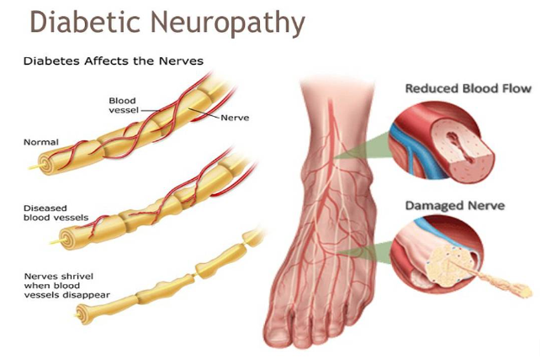
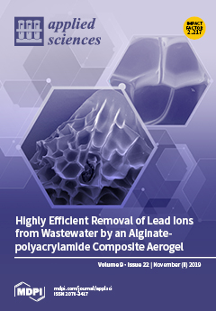
“Wound reduction was measured at two weeks and was found to be significantly reduced in 75% of PBM treated ulcers.”

Authors: Houreld N.
Title: Healing Effects of Photobiomodulation on Diabetic Wounds.
Journal: Applied Sciences, 2019
Link: https://doi.org/10.3390/app9235114

“The Early Treatment Diabetic Retinopathy Study (ETDRS) has shown the benefit of focal laser photocoagulation in decreasing the frequency of persistent macular edema and increasing the chance of visual improvement.”

Authors: Yapislar H, Gurler EB.
Title: Management of Microcomplications of Diabetes Mellitus: Challenges, Current Trends, and Future Perspectives in Treatment.
Journal: Biomedicines, 2024
Link: https://doi.org/10.3390/biomedicines12091958

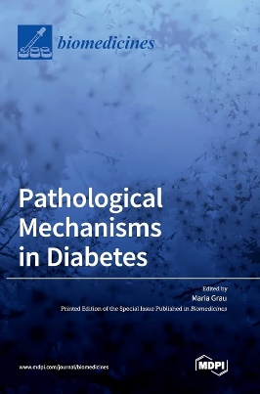
“PBM emerges as a promising adjunctive therapy for managing diabetic neuropathy, wound healing, and glycemic control.”

Authors: Perrier Q, Moro C, Lablanche S.
Title: Diabetes in spotlight: current knowledge and perspectives of photobiomodulation utilization
Journal: Frontiers in Endocrinology, 2024
Link: https://www.frontiersin.org/journals/endocrinology/articles/10.3389/fendo.2024.1303638

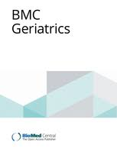
“Deep tissue laser therapy significantly reduced pain and improved the quality of life of older patients with painful diabetic peripheral neuropathy.”

Authors: Chatterjee P, Srivastava AK, Kumar DA, et al.
Title: Effect of deep tissue laser therapy treatment on peripheral neuropathic pain in older adults with type 2 diabetes: a pilot randomized clinical trial.
Journal: BMC Geriatrics, 2019
Link: https://pubmed.ncbi.nlm.nih.gov/31405365/

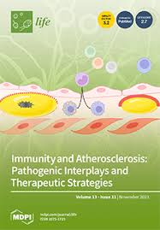
“PBM at different wavelengths has shown positive results with regards to wound healing and fibroblast proliferation. It is also worth taking into consideration that red and NIR wavelengths have established beneficial effects in diabetic ulcer care.”

Authors: Purbhoo-Makan M, Houreld NN, Enwemeka CS.
Title: The Effects of Blue Light on Human Fibroblasts and Diabetic Wound Healing.
Journal: Life (Basel), 2022
Link: https://www.ncbi.nlm.nih.gov/pmc/articles/PMC9505688/

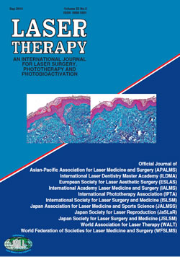
“PBM at different wavelengths has shown positive results with regards to wound healing and fibroblast proliferation. It is also worth taking into consideration that red and NIR wavelengths have established beneficial effects in diabetic ulcer care.”

Authors: Cg SK, Maiya AG, Hande HM, Vidyasagar S, Rao K, Rajagopal KV.
Title: Efficacy of low level laser therapy on painful diabetic peripheral neuropathy.
Journal: Laser Therapy, 2015
Link: https://www.ncbi.nlm.nih.gov/pmc/articles/PMC4639677/

“A systematic review of four randomized clinical trials in which laser therapy was administered to patients with a diabetic foot ulcer over 2 to 16 weeks found favorable outcomes regarding ulcer size and time to healing.”
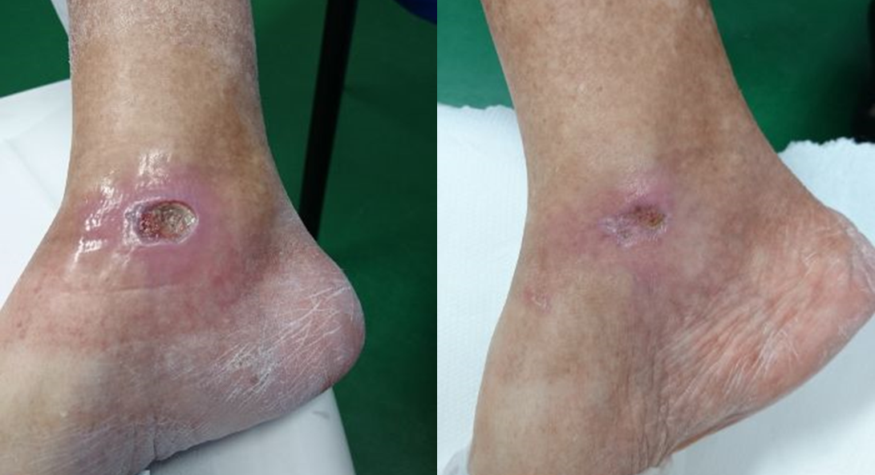

Authors: Bavaresco T, Pires AUB, Moraes VM, Osmarin VM, Silveira DT, Lucena AF.
Title: Low-level laser therapy for treatment of venous ulcers evaluated with the Nursing Outcome Classification: study protocol for a randomized controlled trial.
Journal: Trials, 2018
Link: https://www.ncbi.nlm.nih.gov/pmc/articles/PMC6044085/

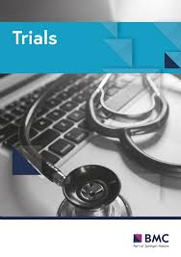

“Low-level laser therapy was a noninvasive, quick and safe intervention, which increased thyroid hormones and improved thyroid function. Moreover, there was no risk of developing malignant nodules.”
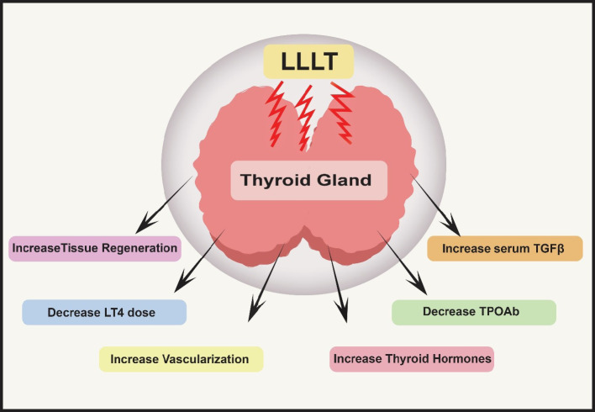
Authors: Hossein-Khannazer N, Kazem Arki M, Keramatinia L, Rezaei-Tavirani M.
Title: Low-Level Laser Therapy in the Treatment of Autoimmune Thyroiditis.
Journal: Laser Therapy, 2015
Link: https://pubmed.ncbi.nlm.nih.gov/36743139/

“Brain diseases, including neurodegenerative diseases and neuropsychiatric disorders, have been a major public health problem. There is no drug that can completely reverse the progression without side effects, whereas PBMT has been demonstrated to be capable of delaying the progression of disability, promoting brain function recovery, and reducing the frequency of relapses.”
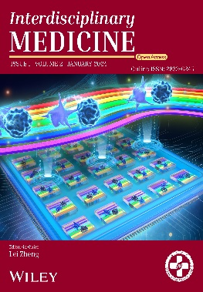
Authors: S. Dong, H. Ren, R. Zhang, X. Wei,
Title: Recent advances in photobiomodulation therapy for brain diseases
Journal: Interdisciplinary Medicine, 2024
Link: https://doi.org/10.1002/INMD.20230027

Neuro-psychiatry
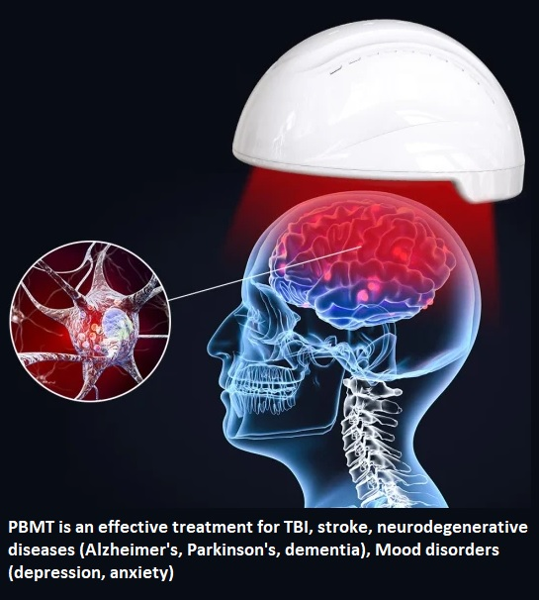

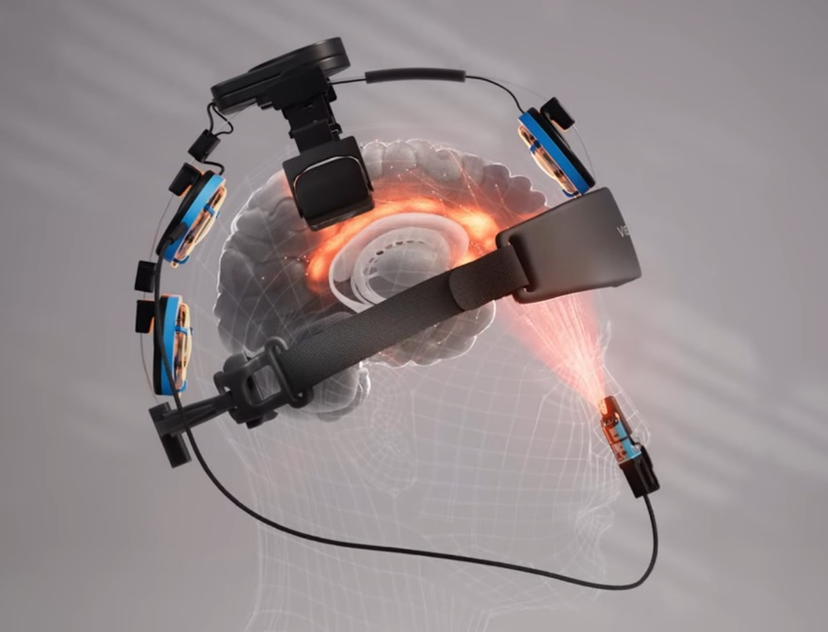

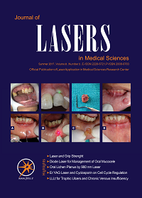
“Low-level laser therapy leads to a reduction in inflammatory immune cells, including TH1 and TH17, inhibits inflammation, and augments brain tissue regeneration.”

Authors: Hossein-Khannazer N, Kazem Arki M, Keramatinia A, Rezaei-Tavirani M.
Title: The Role of Low-Level Laser Therapy in the Treatment of Multiple Sclerosis: A Review Study
Journal: Journal of Lasers in Medical Sciences, 2021
Link: https://pubmed.ncbi.nlm.nih.gov/35155173/


“Patients saw benefit often within four treatments and resolution of depressive symptoms occurred within 4 weeks for some.”

Authors: Henderson TA, Morries LD.
Title: Multi-Watt Near-Infrared Phototherapy for the Treatment of Comorbid Depression: An Open-Label Single-Arm Study.
Journal: Frontiers in Psychiatry, 2017
Link: https://pubmed.ncbi.nlm.nih.gov/29033859/

“PBMT can be classified as strongly recommended for moderate grade of major depressive disorder (MDD) and recommended for anxiety disorder.”

Authors: Montazeri, K., Farhadi, M., Fekrazad, R. et al.
Title: Photobiomodulation therapy in mood disorders: a systematic review.
Journal: Lasers in Medical Science, 2022
Link: https://doi.org/10.1007/s10103-022-03641-w


“This systematic review clearly demonstrates the therapeutic role of PBM combined therapies, as well as their potential to improve treatment efficacy and reduce side effects across a wide range of central and peripheral neurological disorders.”

Authors: Farazi N, Salehi-Pourmehr H, Farajdokht F, Mahmoudi J, Sadigh-Eteghad S.
Title: Photobiomodulation combination therapy as a new insight in neurological disorders: a comprehensive systematic review.
Journal: BMC Neurology, 2024
Link: https://pubmed.ncbi.nlm.nih.gov/38504162/

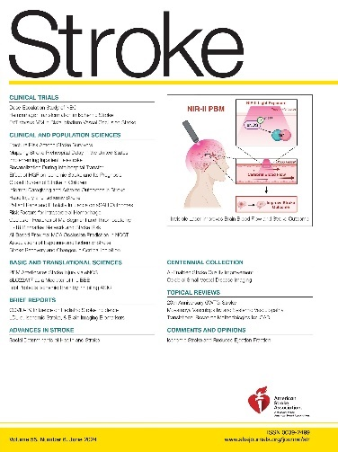
“Near-infrared II photobiomodulation could offer a noninvasive and low-risk adjunctive therapy for stroke injury.”

Authors: Yokomizo S, Kopp T, Roessing M, et al.
Title: Near-Infrared II Photobiomodulation Preconditioning Ameliorates Stroke Injury via Phosphorylation of eNOS.
Journal: Stroke, 2024 (American Heart Association)
Link: https://pubmed.ncbi.nlm.nih.gov/38572660/

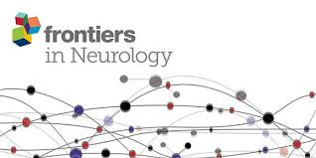
“Infrared photobiomodulation embodies a remarkable and powerful tool for influencing mitochondrial function, inflammation, perfusion, and tissue repair mechanisms in the brain and other tissues.”

Authors: Henderson TA.
Title: Can infrared light really be doing what we claim it is doing? Infrared light penetration principles, practices, and limitations.
Journal: Frontiers in Neurology, 2024
Link: https://pubmed.ncbi.nlm.nih.gov/39263274/

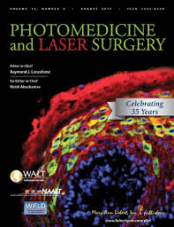
“There was significant improvement after 12 weeks of PBM. Increased function, better sleep, fewer angry outbursts, less anxiety, and wandering were reported post-PBM. There were no negative side effects.”

Authors: Saltmarche AE, Naeser MA, Ho KF, Hamblin MR, Lim L.
Title: Significant Improvement in Cognition in Mild to Moderately Severe Dementia Cases Treated with Transcranial Plus Intranasal Photobiomodulation: Case Series Report.
Journal: Photomedicine and Laser Surgery, 2017
Link: https://pubmed.ncbi.nlm.nih.gov/28186867/

“PBM has shown potential to halt or even reverse the progression of AD, as evidenced by improvements in cognitive impairment and memory across various published studies.”

Authors: Lim L.
Title: Modifying Alzheimer's disease pathophysiology with photobiomodulation: model, evidence, and future with EEG-guided intervention.
Journal: Frontiers in Neurology, 2024
Link: https://pubmed.ncbi.nlm.nih.gov/39246604/

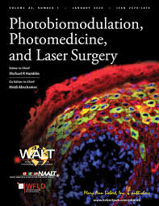
“Simultaneous intranasal and transcranial PBM (itPBM) is emerging as a possible treatment for cognitive and psychological sequelae of brain injury with evidence of remote effects on other body systems.”
“

Authors: Johnson PK, Fino PC, Wilde EA, et al.
Title: The Effect of Intranasal Plus Transcranial Photobiomodulation on Neuromuscular Control in Individuals with Repetitive Head Acceleration Events.
Journal: Photobiomodulation, Photomedicine, and Laser Surgery, 2024
Link: https://doi.org/10.1089/pho.2023.017

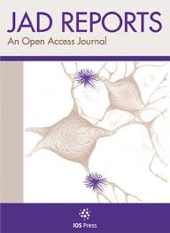
“There was significant improvement at 1 month on post-traumatic stress disorder (PTSD), depression, pain, and sleep.”

“

Authors: Naeser MA, Martin PI, Ho MD, et al.
Title: Transcranial Photobiomodulation Treatment: Significant Improvements in Four Ex-Football Players with Possible Chronic Traumatic Encephalopathy.
Journal: Journal of Alzheimer's Disease Reports, 2011
Link: https://www.ncbi.nlm.nih.gov/pmc/articles/PMC9912826/

“A total of eleven randomized controlled trials was included in this meta-analysis, and the combined data suggest that PBM may be an efficacious depression treatment.”
“

Authors: Ji Q, Yan S, Ding J, et al.
Title: Photobiomodulation improves depression symptoms: a systematic review and meta-analysis of randomized controlled trials
Journal: Frontiers in Psychiatry, 2024
Link: https://pubmed.ncbi.nlm.nih.gov/38356614/

“Measures of mobility, cognition, dynamic balance and fine motor skill were significantly improved (p < 0.05) with PBM treatment for 12 weeks and up to one year.”
“

Authors: Liebert A, Bicknell B, Laakso EL, et al.
Title: Improvements in clinical signs of Parkinson's disease using photobiomodulation: a prospective proof-of-concept study.
Journal: BMC Neurology, 2021
Link: https://pubmed.ncbi.nlm.nih.gov/34215216/

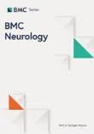
“Transcranial photobiomodulation has demonstrated its value as a treatment for neurological and neurodegenerative conditions, including Alzheimer’s disease.”

Authors: Zomorrodi, R., Loheswaran, G., Pushparaj, A. et al.
Title: Pulsed Near Infrared Transcranial and Intranasal Photobiomodulation Significantly Modulates Neural Oscillations: a pilot exploratory study.
Journal: Scientific Reports, 2019
Link: https://doi.org/10.1038/s41598-019-42693-x

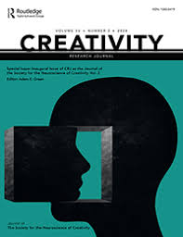
“Transcranial photobiomodulation may help the brain switch from a state of mind-wandering (DMN) to a state of focused attention (salience and central executive networks) more readily.”

Authors: Peña, J. et al.
Title: Enhancement of Divergent Creative Thinking After Transcranial Near-Infrared Photobiomodulation Over the Default Mode Network
Journal: Creativity Research Journal, 2024
Link: https://doi.org/10.1080/10400419.2023.2219953


“PBM balances excitatory stimulation with inhibition, indicating that PBM may reduce excitotoxicity which is relevant to the maintenance of a healthy brain.”

Authors: Staelens M, Di Gregorio E, Kalra AP, et al.
Title: Near-Infrared Photobiomodulation of Living Cells, Tubulin, and Microtubules In Vitro.
Journal: Frontiers in Medical Technology, 2022
Link: https://pubmed.ncbi.nlm.nih.gov/35600165/

“It has been demonstrated that PBMT could play a beneficial role in the treatment of brain diseases in numerous animal experiments and clinical trials for neurodegenerative diseases, brain injury, mental diseases and the improvement of normal brain function (such as enhancement of mood, sleep quality, cognitive abilities, etc.).”

Authors: S. Dong, H. Ren, R. Zhang, X. Wei,
Title: Recent advances in photobiomodulation therapy for brain diseases
Journal: Interdisciplinary Medicine, 2024
Link: https://doi.org/10.1002/INMD.20230027

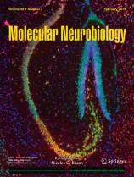
“Brain PBM therapy enhances the metabolic capacity of neurons and stimulates anti-inflammatory, anti-apoptotic, and antioxidant responses, as well as neurogenesis and synaptogenesis. Its therapeutic role in disorders such as dementia and Parkinson’s disease, as well as to treat stroke, brain trauma, and depression has gained increasing interest.”

Authors: Salehpour, F., Mahmoudi, J., Kamari, F. et al.
Title: Brain Photobiomodulation Therapy: a Narrative Review.
Journal: Molecular Neurobiology, 2017
Link: https://doi.org/10.1007/s12035-017-0852-4

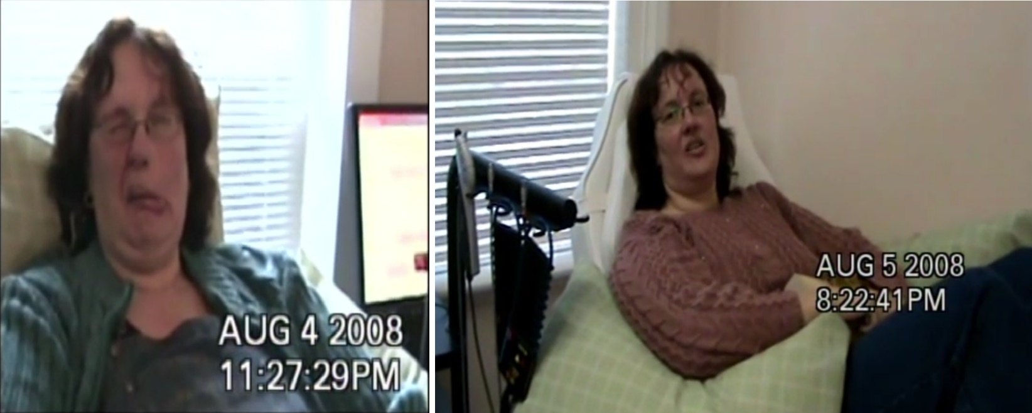Dystonia: before and after PBM therapy
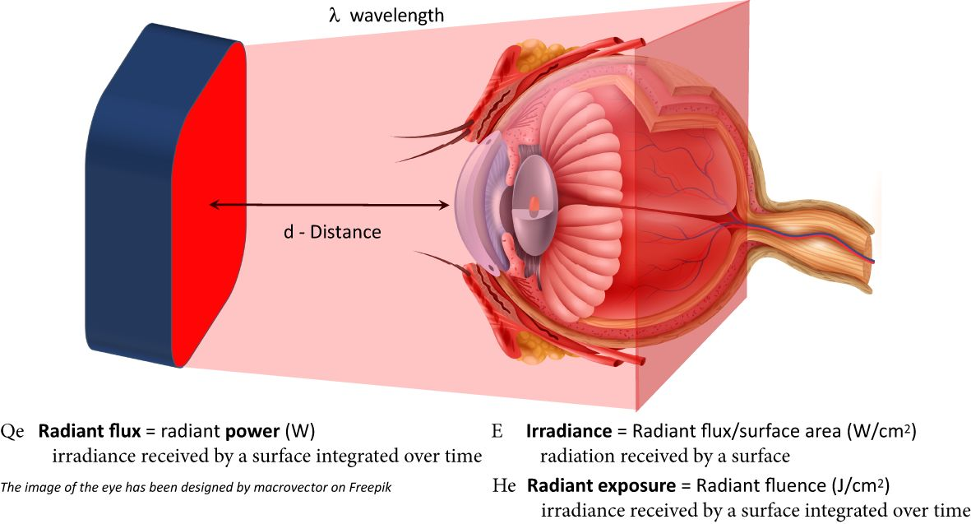
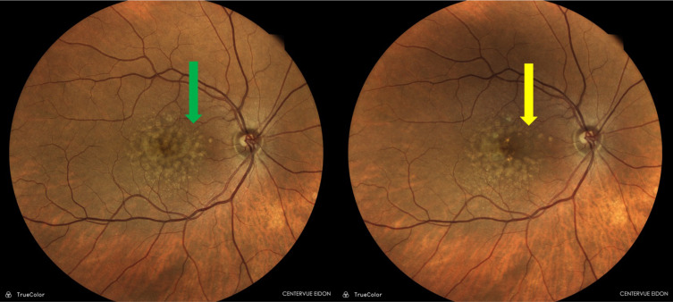
Figure 3. Patient underwent photobiomodulation therapy using the Valeda Light Delivery System and showed a reduction in drusen at the 1-year follow-up examination. Retinography showing the comparison before (green arrow) and after treatment (yellow arrow).

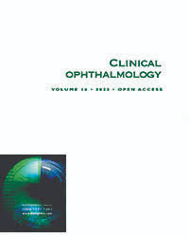
Authors: Siqueira RC.
Title: Photobiomodulation Using Light-Emitting Diode (LED) for Treatment of Retinal Diseases.
Journal: Clinical Ophthalmology, 2024
Link: https://pubmed.ncbi.nlm.nih.gov/38283180/

“Mitochondria are critical for cellular health regulation and disease progression. Mitochondrial dysfunction, oxidative damage, and inflammation are hallmarks of many degenerative diseases, including ocular conditions such as ROP, age-related macular degeneration (AMD), retinitis pigmentosa (RP), diabetic retinopathy (DR), and diabetic macular edema (DME).
Dysfunction at the mitochondrial level limits cellular energy (ATP) production, increases the generation of reactive oxygen species (ROS), and propagates apoptotic pathways. Mitochondrial repair and attenuation of oxidative stress are key to the survival of the retina.
The antioxidant and anti-inflammatory effect of PBM therapy is well-established. The underlying biological mechanisms of PBM therapy are complex and multidimensional but the growing scientific and clinical evidence demonstrating positive clinical findings in ocular disease has strengthened the use of PBM as a treatment approach for ocular disease and damage.”

Authors: Valter, Krisztina et al.
Title: Photobiomodulation use in ophthalmology - an overview of translational research from bench to bedside
Journal: Frontiers in ophthalmology, 2024
Link: https://pubmed.ncbi.nlm.nih.gov/39211002/

Ophthalmology
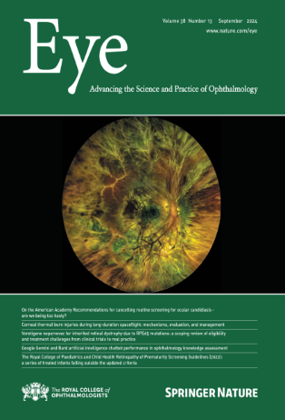
“136 eyes of 123 chronic CSCR patients treated with half dose PDT exhibited an improvement in VA from 0.36 to 0.15 logMAR, 36 months following treatment from half dose PDT, 97% of eyes with complete resolution of SRF at this point”

Authors: Khandhadia, S., Thulasidharan, S., Hoang, N.T.V. et al.
Title: Real world outcomes of photodynamic therapy for chronic central serous chorioretinopathy
Journal: Eye 2023 (Official journal of The Royal College of Ophthalmologists)
Link: https://doi.org/10.1038/s41433-022-02370-2

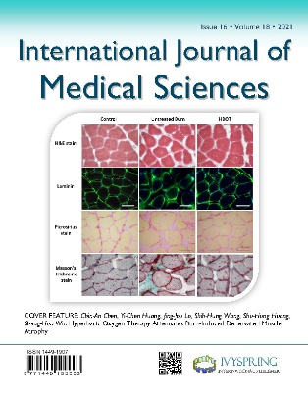
“NIR light can also help brains to recover from atherothrombotic stroke, brain injury, and neurodegeneration”

Authors: Zhu Q, Xiao S, Hua Z, Yang D, Hu M, Zhu YT, Zhong H.
Title: Near Infrared (NIR) Light Therapy of Eye Diseases: A Review
Journal: International Journal of Medical Sciences 2021
Link: https://www.medsci.org/v18p0109.htm

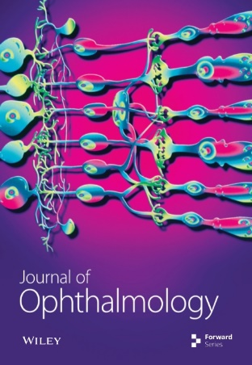
“At 6 months, central retinal thickness declined 24±5 microns (vs 120±97 microns in comparison) and VA improved 6±5 letters (vs 3±4 letter decrease in comparison)”

Authors: Muste JC, Russell MW, Singh RP.
Title: Photo biomodulation Therapy for Age-Related Macular Degeneration and Diabetic Retinopathy: A Review.
Journal: Clinical Ophthalmology 2021.
Link: https://www.ncbi.nlm.nih.gov/pmc/articles/PMC8421781/

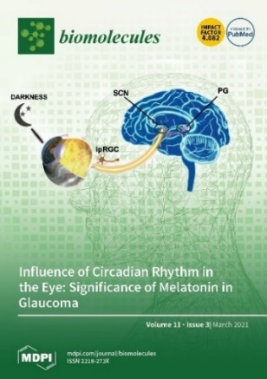
“Light irradiation via PBM can increase the rate of mitochondrial ATP production and suppress inflammatory responses in the retina, thus playing a positive therapeutic role in many retinal diseases.”

Authors: Zhang CX, Lou Y, Chi J, Bao XL, Fan B, Li GY.
Title: Considerations for the Use of Photobiomodulation in the Treatment of Retinal Diseases
Journal: Biomolecules. 2022
Link: https://www.ncbi.nlm.nih.gov/pmc/articles/PMC9775242/

“Photobiomodulation is a non-invasive approach that showed promising outcomes in various ocular conditions from the ocular surface to the back of the eye, thus rising to the attention of the ophthalmology scientific community.
The results obtained in ocular surface diseases are supported by an extensive literature, opening the novel scenario of using this technology not only for DED/MGD treatment but also for its prophylaxis after cataract surgery.”

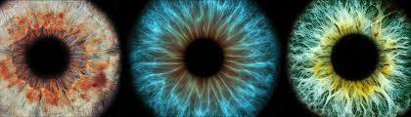

Authors: Cannas C, Pintus B, Corgiolu L, Borrelli E, Boscia G, Toro MD, Giannaccare G.
Title: Current Applications and Future Perspectives of Photobiomodulation in Ocular Diseases: A Narrative Review.
Journal: Applied Sciences, 2024
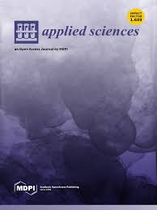


“PBM has shown significant promise in retinal diseases, especially in managing AMD. Clinical studies have reported reduced drusen volume and improved visual acuity and contrast sensitivity in patients with dry AMD.
Additionally, PBM has shown promise in promoting corneal wound healing, particularly for corneal ulcers, by facilitating cellular repair and potentially speeding recovery times. It is also being evaluated for its role in improving recovery after refractive surgeries like LASIK and PRK, with preliminary findings suggesting reduced inflammation and accelerated healing, leading to enhanced visual outcomes post-surgery.”

\

Authors: Garg D, Daigavane S
Title: Photobiomodulation in Ophthalmology: A Comprehensive Review of Bench-to-Bedside Research and Clinical Integration.
Journal: Cereus, 2024

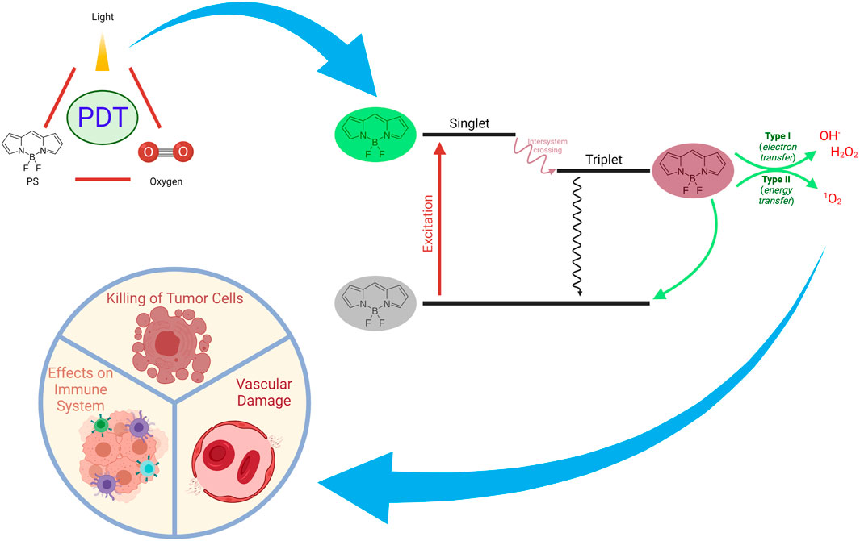
Mechanisms of Action of PDT on Tumors. PDT can exert a plethora of actions such as inducing immune responses, direct killing of tumor cells, and damaging vascular

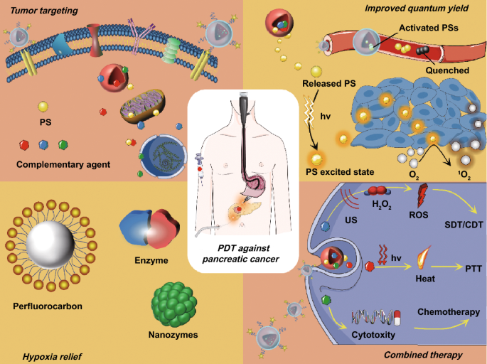Schematic illustration of PS-loaded NPs for localized photodynamic destruction of PCa
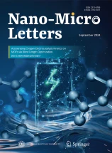
Authors: Yang, H., Liu, R., Xu, Y. et al.
Title: Photosensitizer Nanoparticles Boost Photodynamic Therapy for Pancreatic Cancer Treatment.
Journal: Nano-Micro Letters, 2021
Link: https://doi.org/10.1007/s40820-020-00561-8

“Photodynamic therapy (PDT) has been used as an anti-tumor treatment method for a long time and photosensitizers (PS) can be used in various types of tumors.
Various novel PDT approaches have been studied and developed over the last decades in order to be used against tumors. Preclinical and clinical applications of PDT and PDD have yielded promising results. Topical and systemic administrations of PSs have been utilized in the clinical setting.
In addition, several PDT approaches have been approved by major regulatory bodies including the FDA in the United States and the European Medicines Agency (EMA) in Europe.”

Authors: Gunaydin G, Gedik ME and Ayan S
Title: Photodynamic Therapy for the Treatment and Diagnosis of Cancer–A Review of the Current Clinical Status.
Journal: Frontiers in Chemistry 2021
Link: https://www.frontiersin.org/journals/chemistry/articles/10.3389/fchem.2021.686303/full

Oncology
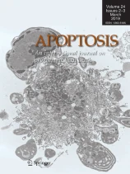
“PBMT had also been shown to ameliorate muscle atrophy through enhancing PI3K/AKT pathway to suppress MAFbx and MuRF-1 expression.”

Authors: Li, Y., Chen, Y., Liao, Y. et al.
Title: Photobiomodulation therapy moderates cancer cachexia-associated muscle wasting through activating PI3K/AKT/FoxO3a pathway.
Journal: Apoptosis 2024
Link: https://pubmed.ncbi.nlm.nih.gov/38598070/

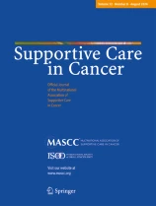
“PBMT may be effective in preventing grades 2 and 3 RD.”

Authors: Gobbo, M., Rico, V., Marta, G.N. et al.
Title: Photobiomodulation therapy for the prevention of acute radiation dermatitis: a systematic review and meta-analysis
Journal: Supportive Care in Cancer 2023
Link: https://pubmed.ncbi.nlm.nih.gov/36952036/

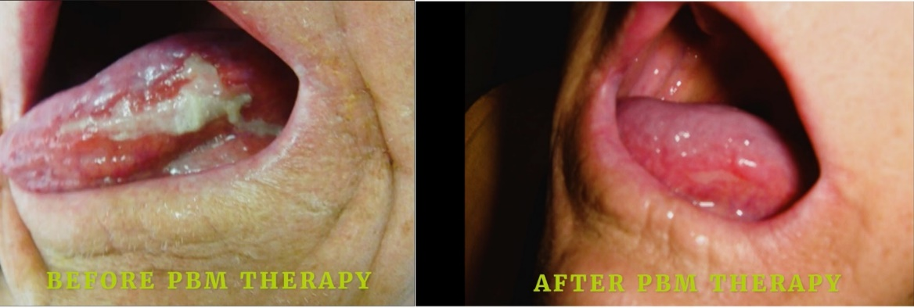
“Patients submitted to PBMT reported better QoL at the end of the treatment compared with the control group. PBMT used for the management of OM preserves the QoL of patients with head and neck cancer.”

Authors: Potrich, A.R., Só, B.B., Schuch, L.F. et al.
Title: Impact of Photobiomodulation for prevention of oral mucositis on the quality of life of patients with head and neck cancer: a systematic review.
Journal: Lasers in Medical Science 2024.
Link: https://doi.org/10.1007/s10103-023-03940-w

“PMB therapy contributes to faster healing of painful oral lesions in oncological patients, and thus their treatment time and return to the appropriate QoL is shorter.”

Authors: Jabłoński P, Musiał M, Wiench R, Stefanik N, Olchowy C, Matys J, Skaba D, Grzech-Leśniak K.
Title: Photobiomodulation Therapy in the Treatment of Oral Mucositis-A Case Report.
Journal: Medicina (Kaunas) 2022.
Link: https://www.ncbi.nlm.nih.gov/pmc/articles/PMC9147415/

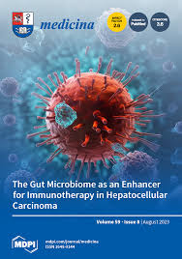
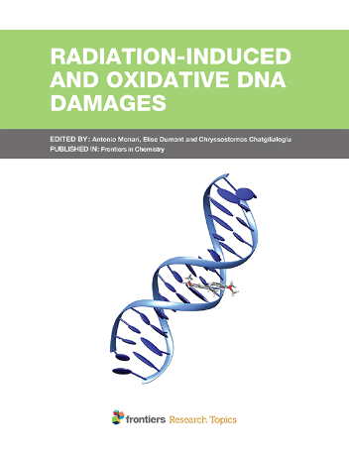
“The combination of PDT and immunotherapy may not only efficiently eliminate the target tumor; but also can take out tumor cells and metastases.”

Authors: Gunaydin G, Gedik ME and Ayan S
Title: Photodynamic Therapy for the Treatment and Diagnosis of Cancer–A Review of the Current Clinical Status.
Journal: Frontiers in Chemistry 2021
Link: https://www.frontiersin.org/journals/chemistry/articles/10.3389/fchem.2021.686303/full

“The current review revealed the promising effects of PDT on different oral squamous cell carcinoma (OSCC) cell lines using different PDT protocols.”

Authors: Saberi S, Hakimiha N, Alaeddini M, Etemad-Moghadam S, Roudbari P, Shahabi S.
Title: In Vitro Anti-tumor Effects of Photodynamic Therapy on Oral Squamous Cell Carcinoma: A Review.
Journal: Journal of Lasers in Medical Sciences 2022
Link: https://www.ncbi.nlm.nih.gov/pmc/articles/PMC10082907/


“Photodynamic therapy offers promise for cancer treatment.”

Authors: Karishma Kailass, Postdoctoral Fellow at Brigham and Women’s Hospital, Broad Institute of MIT and Harvard, Harvard Medical School.
Title: Photodynamic therapy offers promise for cancer treatment
Journal: University of Toronto Mississauga
Link: https://www.utm.utoronto.ca/main-news/photodynamic-therapy-offers-promise-cancer-treatment

“Clinical trials have shown no adverse effects after therapy and demonstrated an improvement in overall survival related to the reduction of these side effects, such as oral mucositis, RD and lymphedema, associated with the reduction of inflammation and pain, promotion of tissue reparation, reduction of fibrosis, and nerve regeneration.”

Authors: Ramos Rocha S, da Costa Ferreira SA, Ramalho A, Conceição Gouveia Santos VL, Cristina Nogueira P.
Title: Photobiomodulation Therapy in the Prevention and Treatment of Radiodermatitis in Breast Cancer Patients: Systematic Review.
Journal: Journal of Lasers in Medical Sciences 2022
Link: https://www.ncbi.nlm.nih.gov/pmc/articles/PMC9841382/

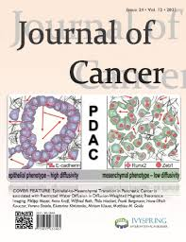
“PDT has been the subject of numerous clinical studies and has proven to be an effective strategy for cancer therapy. Clinical studies revealed that PDT could prolong survival in patients with inoperable cancers and significantly improve quality of life.”

Authors: Wang K, Yu B, Pathak JL.
Title: An update in clinical utilization of photodynamic therapy for lung cancer.
Journal: Journal of Cancer 2021
Link: https://www.ncbi.nlm.nih.gov/pmc/articles/PMC7797657/

“Laser treatment with ablative fractional lasers and vascular lasers appears to be an effective treatment for patients with chronic radiation fibrosis and dermatitis.”

Authors: Wilson B, Shah R, Menzer C, Aleisa A, Rossi A.
Title: Laser therapy as a treatment for chronic radiation fibrosis.
Journal: Journal of Lasers in Medical Sciences 2023
Link: https://www.ncbi.nlm.nih.gov/pmc/articles/PMC10099494/

“Our case highlights a positive outcome of PDT treatment of an HIV/HPV-positive patient with complete clearance of margins and recurrences.”

Authors: Jomsky M, Summa CH, Zarraga MB, Demory Beckler M.
Title: Photodynamic Therapy Using Intense Pulse Light to Treat an HIV Patient With Perianal Squamous Cell Carcinoma: A Case Report.
Journal: Cureus 2022
Link: https://pubmed.ncbi.nlm.nih.gov/36072171/


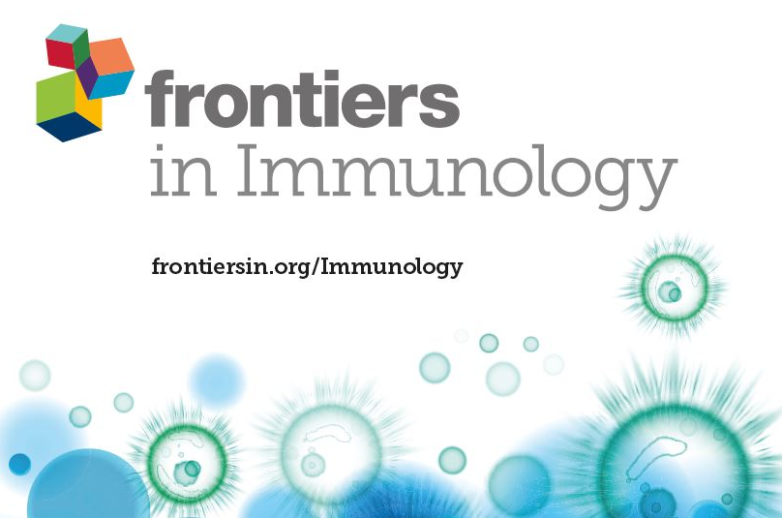
“PDT has demonstrated promising results in the treatment of different malignancies, including superficial bladder cancer, early and obstructive lung cancer, Barrett’s esophagus, head and neck cancers, and skin cancer.”

Authors: Jia J, Wu X, Long G, Yu J, He W, Zhang H, Wang D, Ye Z, Tian J.
Title: Revolutionizing cancer treatment: nanotechnology-enabled photodynamic therapy and immunotherapy with advanced photosensitizers
Journal: Frontiers in Immunology 2023
Link: https://www.frontiersin.org/journals/immunology/articles/10.3389/fimmu.2023.1219785/full

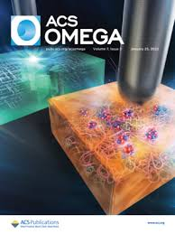
“PDT is an established alternative method for treating cancer. Strong specificity in tumor destruction and the feasibility of combining with other therapeutic agents are the major advantages associated with PDT.”

Authors: Itoo AM, Paul M, Padaga SG, Ghosh B, Biswas S. Nanotherapeutic Intervention in Photodynamic Therapy for Cancer.
Title: Nanotherapeutic Intervention in Photodynamic Therapy for Cancer
Journal: ACS Omega 2022
Link: https://www.ncbi.nlm.nih.gov/pmc/articles/PMC9773346/


“Alleviation of the side effects of cancer therapy has so far been one of the most impressive applications of PBM.”

Authors: Hamblin, M.R.
Title: Photobiomodulation and Light Therapy in Oncology.
Journal: Orofacial Supportive Care in Cancer, 2022
Link: https://www.ncbi.nlm.nih.gov/pmc/articles/PMC9773346/


“Photobiomodulation introduces the therapeutic effect of light into our brain. It triggers the body to restore its natural balance or homeostasis. When we do that, we call upon the body’s innate ability to heal.”



Title: How Alzheimer’s disease could be cured by shining light directly into the brain
Link: https://www.telegraph.co.uk/science/2020/01/05/alzheimers-disease-could-cured-shining-light-directly-brain/

“It is known that during aging, the function of the nervous system deteriorates over time (senescence), which may result in age-related disorders, such as a higher susceptibility to infectious diseases, autoimmune and degenerative processes, or cancer.
Photobiomodulation (PBM) is a non-pharmacological therapy that has a promising application to treat diverse neurological illnesses linked to age, such as AD and PD.
It has been observed that PBM increases cerebral blood flow and energy metabolism in the brain, and it also has antioxidant effects. Also, one of the most accepted theories about the effects of PBM postulates that it causes activation of the mitochondrial enzyme cytochrome c oxidase (CCO), leading to an increase in the production of mitochondrial adenosine triphosphate (ATP), which, in turn, may improve the cell’s metabolic activity.”
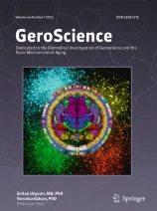
Authors: Rodríguez-Fernández, L., Zorzo, C. & Arias, J.L.
Title: Photobiomodulation in the aging brain: a systematic review from animal models to humans.
Journal: Scientific Reports, 2021
Link: https://doi.org/10.1007/s11357-024-01231-y

Longevity

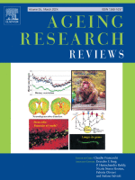
“Overall, epigenetic reprogramming is currently the most promising strategy to be harnessed for age reversal and human rejuvenation.”



Authors: Pereira B, Correia FP, Alves IA, et al.
Title: Epigenetic reprogramming as a key to reverse ageing and increase longevity.
Journal: Ageing Research Reviews, 2024
Link: https://pubmed.ncbi.nlm.nih.gov/38272265/

“PBM relies on the presence of chromophores, several of which exist in the mitochondrial membrane. By absorbing photons, these chromophores can induce different signaling pathways, and thus allow light to influence overall mitochondria and cell behavior.”

“By applying three consecutive treatments at 24-h intervals, we were able to obtain a lasting rejuvenating effect on aged MSCs. Our findings are of particular significance for improving autologous stem cell transplantation in older individuals who need such therapies most.”

(MSCs: Mesenchymal stem cells)

Authors: Eroglu, B., Genova, E., Zhang, Q. et al.
Title: Photobiomodulation has rejuvenating effects on aged bone marrow mesenchymal stem cells.
Journal: Scientific Reports, 2021
Link: https://doi.org/10.1038/s41598-021-92584-3

“Recently, photobiomodulation, the application of red to infrared light (λ=600-1000nm) on body tissues has been reported to alter the course of aged decline. These wavelengths are absorbed by cytochrome c oxidase, the rate limiting enzyme in mitochondrial respiration, increasing its activity along with mitochondrial membrane potential and ATP production

In conclusion, photobiomodulation has been shown to alter the course of ageing in the central nervous system, by improving the survival and function of neurons and reducing gliosis and inflammation.”

Authors: Mitrofanis J, Jeffery G.
Title: Does photobiomodulation influence ageing?
Journal: Aging (Albany NY), 2018
Link: https://www.ncbi.nlm.nih.gov/pmc/articles/PMC6188498/

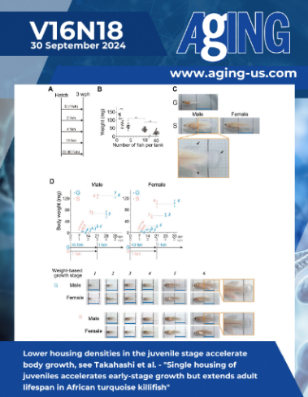

“Increasing evidence suggests an important role for light in regulation of aging and longevity.”

Authors: Shen J, Tower J. Effects of light on aging and longevity.
Title: Effects of light on aging and longevity
Journal: Ageing Research Reviews, 2019
Link: https://www.ncbi.nlm.nih.gov/pmc/articles/PMC6663583/

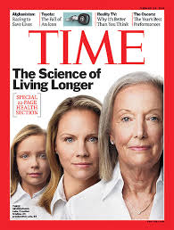
“Chronic conditions such as heart disease and even neurodegenerative disorders like Alzheimer’s - could be treated in large part by reversing the aging process that leads to them.”

Title: Scientists Have Reached a Key Milestone in Learning How to Reverse Aging
Link: https://time.com/6246864/reverse-aging-scientists-discover-milestone/


“Executive function could be improved using transcranial infrared laser

Title: The Strategic Edge of Neurotech in Enhancing Performance and Decision Making
Link: https://www.forbes.com/councils/forbestechcouncil/2024/04/25/the-strategic-edge-of-neurotech-in-enhancing-performance-and-decision-making/

GLOBAL SCIENTIFIC RESEARCH
Research in photodynamic science has been extensively studied worldwide by scientists, with proven significant improvement in symptoms and reversal of underlying pathology, restoration of normal cells with reduced inflammation and improved mitochondrial function, leading to an overall increase in longevity and metabolic health.

